Weekly Submission report
Name: Rishav Kumar Saw
Batch: B1_Python
Faculty: Kunal Sir

30/03
Problem 1

HomeController.cs
using System.Diagnostics;
using Microsoft.AspNetCore.Mvc;
using Sample.Models;

namespace Sample.Controllers;

public class HomeController : Controller
{
public IActionResult Index()
{
return View(new OrderForm());
}

[HttpPost]
[ValidateAntiForgeryToken]
public IActionResult Index(OrderForm model)
{
if (!ModelState.IsValid)
{
return View(model);
}

ViewData["SuccessMessage"] = "Order submitted successfully.";
return View(model);
}

public IActionResult Privacy()
{
return View();
}

[ResponseCache(Duration = 0, Location = ResponseCacheLocation.None, NoStore = true)]
public IActionResult Error()
{
return View(new ErrorViewModel { RequestId = Activity.Current?.Id ?? HttpContext.TraceIdentifier });
}
}

OrderForm.cs
using System.ComponentModel.DataAnnotations;

namespace Sample.Models;

public class OrderForm
{
[Required(ErrorMessage = "Product name is required.")]
[Display(Name = "Product Name")]
public string? ProductName { get; set; }

[Required(ErrorMessage = "Quantity is required.")]
[Range(1, int.MaxValue, ErrorMessage = "Quantity must be at least 1.")]
public int Quantity { get; set; }

[Display(Name = "Discount Code")]
public string? DiscountCode { get; set; }

public bool ShowDiscountCode => Quantity >= 5;
}

Index.cshtml
@model Sample.Models.OrderForm

@{
ViewData["Title"] = "Order Form";
}

<h1>Order Form</h1>

@if (ViewData["SuccessMessage"] is string successMessage)
{
<div class="alert alert-success">@successMessage</div>
}

<form asp-action="Index" method="post" class="row g-3">
@Html.AntiForgeryToken()

<div class="col-md-6">
<label asp-for="ProductName" class="form-label"></label>
<input asp-for="ProductName" class="form-control" />
<span asp-validation-for="ProductName" class="text-danger"></span>
</div>

<div class="col-md-6">
<label asp-for="Quantity" class="form-label"></label>
<input asp-for="Quantity" class="form-control" type="number" min="1" />
<span asp-validation-for="Quantity" class="text-danger"></span>
</div>

@if (Model.ShowDiscountCode)
{
<div class="col-md-6">
<label asp-for="DiscountCode" class="form-label"></label>
<input asp-for="DiscountCode" class="form-control" />
<span asp-validation-for="DiscountCode" class="text-danger"></span>
</div>
}
else
{
@* Preserve the existing discount code when the field is hidden. *@
<input type="hidden" asp-for="DiscountCode" />
}

<div class="col-12">
<button type="submit" class="btn btn-primary">Submit</button>
</div>
</form>

@section Scripts {
<partial name="_ValidationScriptsPartial" />
}

Problem 2

Middleware.cs
using System.Text;

namespace Sample;

public sealed class ResponseModificationMiddleware
{
private readonly RequestDelegate _next;

public ResponseModificationMiddleware(RequestDelegate next)
{
_next = next;
}

public async Task InvokeAsync(HttpContext context)
{
var originalBodyStream = context.Response.Body;

await using var responseBody = new MemoryStream();
context.Response.Body = responseBody;

try
{
await _next(context);

context.Response.Body.Seek(0, SeekOrigin.Begin);
var responseText = await new StreamReader(context.Response.Body, Encoding.UTF8).ReadToEndAsync();

if (responseText.Contains("Hello", StringComparison.Ordinal))
{
responseText = responseText.Replace("Hello", "Hello - Processed by Middleware", StringComparison.Ordinal);
}

var modifiedBytes = Encoding.UTF8.GetBytes(responseText);
context.Response.ContentLength = modifiedBytes.Length;

context.Response.Body = originalBodyStream;
await context.Response.Body.WriteAsync(modifiedBytes);
}
finally
{
context.Response.Body = originalBodyStream;
}
}
}

Program.cs
using Sample;

var builder = WebApplication.CreateBuilder(args);

// Add services to the container.
// Learn more about configuring OpenAPI at https://aka.ms/aspnet/openapi
builder.Services.AddOpenApi();

var app = builder.Build();

// Configure the HTTP request pipeline.
if (app.Environment.IsDevelopment())
{
app.MapOpenApi();
}

app.UseMiddleware<ResponseModificationMiddleware>();
app.UseHttpsRedirection();

var summaries = new[]
{
"Freezing", "Bracing", "Chilly", "Cool", "Mild", "Warm", "Balmy", "Hot", "Sweltering", "Scorching"
};

app.MapGet("/weatherforecast", () =>
{
var forecast = Enumerable.Range(1, 5).Select(index =>
new WeatherForecast
(
DateOnly.FromDateTime(DateTime.Now.AddDays(index)),
Random.Shared.Next(-20, 55),
summaries[Random.Shared.Next(summaries.Length)]
))
.ToArray();
return forecast;
})
.WithName("GetWeatherForecast");

app.Run();

record WeatherForecast(DateOnly Date, int TemperatureC, string? Summary)
{
public int TemperatureF => 32 + (int)(TemperatureC / 0.5556);
}

Problem 3

Program.cs
using Microsoft.EntityFrameworkCore;
using Sample.Data;
using Sample.Models;

var builder = WebApplication.CreateBuilder(args);

// Add services to the container.
// Learn more about configuring OpenAPI at https://aka.ms/aspnet/openapi
builder.Services.AddDbContext<AppDbContext>(options =>
options.UseInMemoryDatabase("ProductsDb"));

builder.Services.AddOpenApi();

var app = builder.Build();

using (var scope = app.Services.CreateScope())
{
var db = scope.ServiceProvider.GetRequiredService<AppDbContext>();
db.Database.EnsureCreated();

if (!db.Products.Any())
{
db.Products.AddRange(
new Product { Name = "Smartphone X", Price = 699m, Category = "Electronics" },
new Product { Name = "Wireless Headphones", Price = 199m, Category = "Electronics" },
new Product { Name = "Office Chair", Price = 149m, Category = "Furniture" },
new Product { Name = "Desk Lamp", Price = 39m, Category = "Home" },
new Product { Name = "Gaming Laptop", Price = 1299m, Category = "Electronics" },
new Product { Name = "Coffee Maker", Price = 89m, Category = "Kitchen" }
);

db.SaveChanges();
}
}

// Configure the HTTP request pipeline.
if (app.Environment.IsDevelopment())
{
app.MapOpenApi();
}

app.UseHttpsRedirection();

app.MapGet("/api/products", async (AppDbContext db, decimal? minPrice, string? category, string? search) =>
{
IQueryable<Product> products = db.Products;

if (minPrice.HasValue)
{
products = products.Where(p => p.Price >= minPrice.Value);
}

if (!string.IsNullOrWhiteSpace(category))
{
products = products.Where(p => p.Category == category);
}

if (!string.IsNullOrWhiteSpace(search))
{
products = products.Where(p => p.Name.Contains(search));
}

return await products.ToListAsync();
})
.WithName("GetProducts");

var summaries = new[]
{
"Freezing", "Bracing", "Chilly", "Cool", "Mild", "Warm", "Balmy", "Hot", "Sweltering", "Scorching"
};

app.MapGet("/weatherforecast", () =>
{
var forecast = Enumerable.Range(1, 5).Select(index =>
new WeatherForecast
(
DateOnly.FromDateTime(DateTime.Now.AddDays(index)),
Random.Shared.Next(-20, 55),
summaries[Random.Shared.Next(summaries.Length)]
))
.ToArray();
return forecast;
})
.WithName("GetWeatherForecast");

app.Run();

record WeatherForecast(DateOnly Date, int TemperatureC, string? Summary)
{
public int TemperatureF => 32 + (int)(TemperatureC / 0.5556);
}

Product.cs
namespace Sample.Models;

public sealed class Product
{
public int Id { get; set; }
public string Name { get; set; } = default!;
public decimal Price { get; set; }
public string Category { get; set; } = default!;
}

AppDbContext.cs
namespace Sample.Models;

public sealed class Product
{
public int Id { get; set; }
public string Name { get; set; } = default!;
public decimal Price { get; set; }
public string Category { get; set; } = default!;
}

Problem 4

NotificationRequest.cs
public class NotificationRequest
{
public string Type{get; set;}="";
public string Message{get; set;}="";
public string Recipient{get; set;}="";
}

iNotificationService.cs
public interface INotificationService
{
string Type{get;}
Task SendAsync(NotificationRequest request);
}
EmailNotification.cs
public class EmailNotification: INotificationService
{
public string Type=> "Email";
public async Task SendAsync(NotificationRequest request)
{
await Task.Delay(500);

if(new Random().Next(0, 2)==0)
throw new Exception("SMTP failure");
Console.WriteLine($"Email sent to {request.Recipient}");
}
}

SmsNotification.cs
public class SmsNotification: INotificationService
{
public string Type=> "SMS";
public async Task SendAsync(NotificationRequest request)
{
await Task.Delay(500);
if(new Random().Next(0,5)== 0)
throw new TimeoutException("SMS timeout");

Console.WriteLine("SMS sent");
}
}

INotificationFactory.cs
public interface INotificationFactory
{
INotificationService GetService(string Type);
}
NotificationFactory.cs
public class NotificationFactory: INotificationFactory
{
private readonly IEnumerable<INotificationService> _services;
public NotificationFactory(IEnumerable<INotificationService> services)
{
_services= services;
}
public INotificationService GetService(string type)
{
var service= _services.FirstOrDefault(s=> s.Type== type);
if(service== null)
throw new Exception("Invalid notification type");

return service;
}
}

INotificationExecutor.cs
public interface INotificationExecutor
{
Task ExecuteAsync(NotificationRequest request);
}
NotificationExecutor.cs
public class NotificationExecutor: INotificationExecutor
{
private readonly INotificationFactory _factory;
private readonly ILogger<NotificationExecutor> _logger;

public NotificationExecutor(INotificationFactory factory, ILogger<NotificationExecutor> logger)
{
_factory= factory;
_logger= logger;
}

public async Task ExecuteAsync(NotificationRequest request)
{
var service= _factory.GetService(request.Type);
try
{
await service.SendAsync(request);
}
catch(Exception ex)
{
_logger.LogWarning($"Retrying {request.Type}: {ex.Message}");

try
{
await service.SendAsync(request);
}
catch(Exception ex2)
{
_logger.LogError($"Failed after retry: {ex2.Message}");
}
}
}
}

BulkNotificationService.cs
public class BulkNotificationService
{
private readonly INotificationExecutor _executor;
public BulkNotificationService(INotificationExecutor executor)
{
_executor= executor;
}

public async Task SendBulkAsync(List<NotificationRequest> requests)
{
var tasks= requests.Select(r=> _executor.ExecuteAsync(r));
await Task.WhenAll(tasks);
}
}

NotificationController.cs
using Microsoft.AspNetCore.Mvc;

[ApiController]
[Route("api/notifications")]
public class NotificationController: Controller
{
private readonly BulkNotificationService _bulkService;
public NotificationController(BulkNotificationService bulkService)
{
_bulkService= bulkService;
}

[HttpPost("bulk")]
public async Task<IActionResult> SendBulk(List<NotificationRequest> requests)
{
await _bulkService.SendBulkAsync(requests);
return Ok("Processed");
}
}

Program.cs
var builder = WebApplication.CreateBuilder(args);

// Add services to the container.
// Learn more about configuring OpenAPI at https://aka.ms/aspnet/openapi
builder.Services.AddOpenApi();
builder.Services.AddScoped<INotificationService, EmailNotification>();
builder.Services.AddScoped<INotificationService, SmsNotification>();

builder.Services.AddScoped<INotificationFactory, NotificationFactory>();
builder.Services.AddScoped<INotificationExecutor, NotificationExecutor>();
builder.Services.AddScoped<BulkNotificationService>();
var app = builder.Build();

// Configure the HTTP request pipeline.
if (app.Environment.IsDevelopment())
{
app.MapOpenApi();
}

app.UseHttpsRedirection();

var summaries = new[]
{
"Freezing", "Bracing", "Chilly", "Cool", "Mild", "Warm", "Balmy", "Hot", "Sweltering", "Scorching"
};

app.MapGet("/weatherforecast", () =>
{
var forecast = Enumerable.Range(1, 5).Select(index =>
new WeatherForecast
(
DateOnly.FromDateTime(DateTime.Now.AddDays(index)),
Random.Shared.Next(-20, 55),
summaries[Random.Shared.Next(summaries.Length)]
))
.ToArray();
return forecast;
})
.WithName("GetWeatherForecast");

app.Run();

record WeatherForecast(DateOnly Date, int TemperatureC, string? Summary)
{
public int TemperatureF => 32 + (int)(TemperatureC / 0.5556);
}

Problem 5

Cache.cs
using System.Collections.Concurrent;

namespace Sample.Services;

public class Cache
{
private static readonly Lazy<Cache> _instance = new Lazy<Cache>(() => new Cache());
public static Cache Instance => _instance.Value;

private readonly ConcurrentDictionary<string, CacheItem> _cache = new ConcurrentDictionary<string, CacheItem>();
private readonly Timer _cleanupTimer;

private Cache()
{
// Background cleanup every 1 second
_cleanupTimer = new Timer(CleanupExpiredItems, null, 1000, 1000);
}

public void Set(string key, object value, TimeSpan expiry)
{
var item = new CacheItem(value, DateTime.UtcNow.Add(expiry));
_cache[key] = item;
}

public object? Get(string key)
{
if (_cache.TryGetValue(key, out var item))
{
if (item.Expiry > DateTime.UtcNow)
{
return item.Value;
}
else
{
// Remove expired item
_cache.TryRemove(key, out _);
}
}
return null;
}

private void CleanupExpiredItems(object? state)
{
DateTime now = DateTime.UtcNow;
var expiredKeys = _cache.Where(kvp => kvp.Value.Expiry <= now)
.Select(kvp => kvp.Key)
.ToList();

foreach (var key in expiredKeys)
{
_cache.TryRemove(key, out _);
}
}

private class CacheItem
{
public object Value { get; }
public DateTime Expiry { get; }

public CacheItem(object value, DateTime expiry)
{
Value = value;
Expiry = expiry;
}
}
}

31/03
Problem 1

Home page
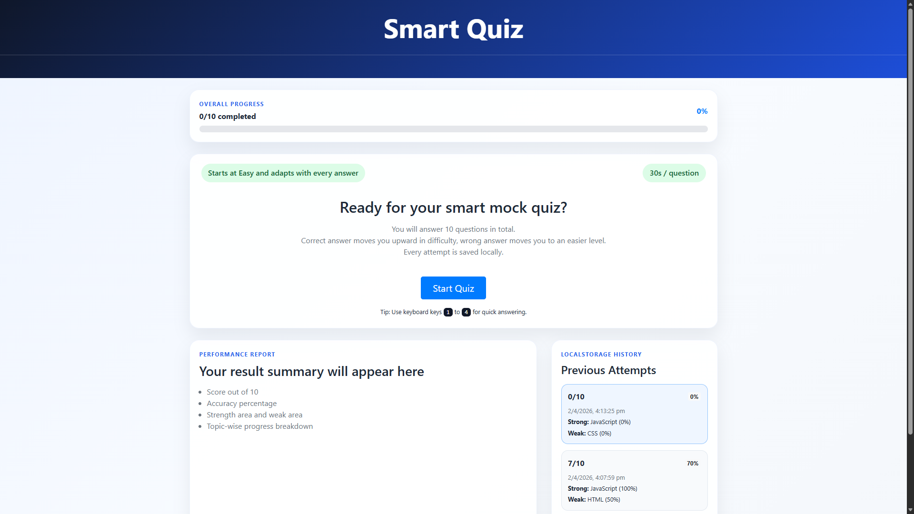

Attempting Quiz
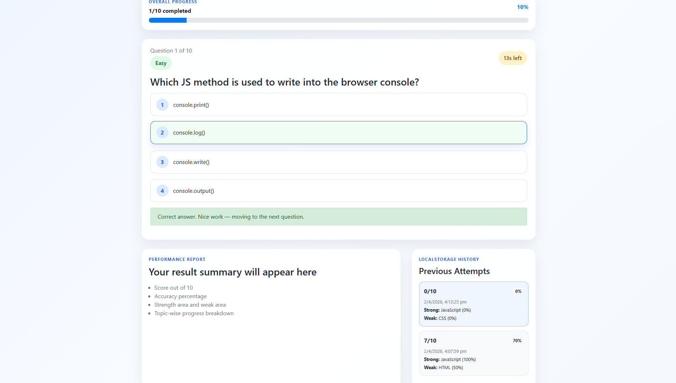
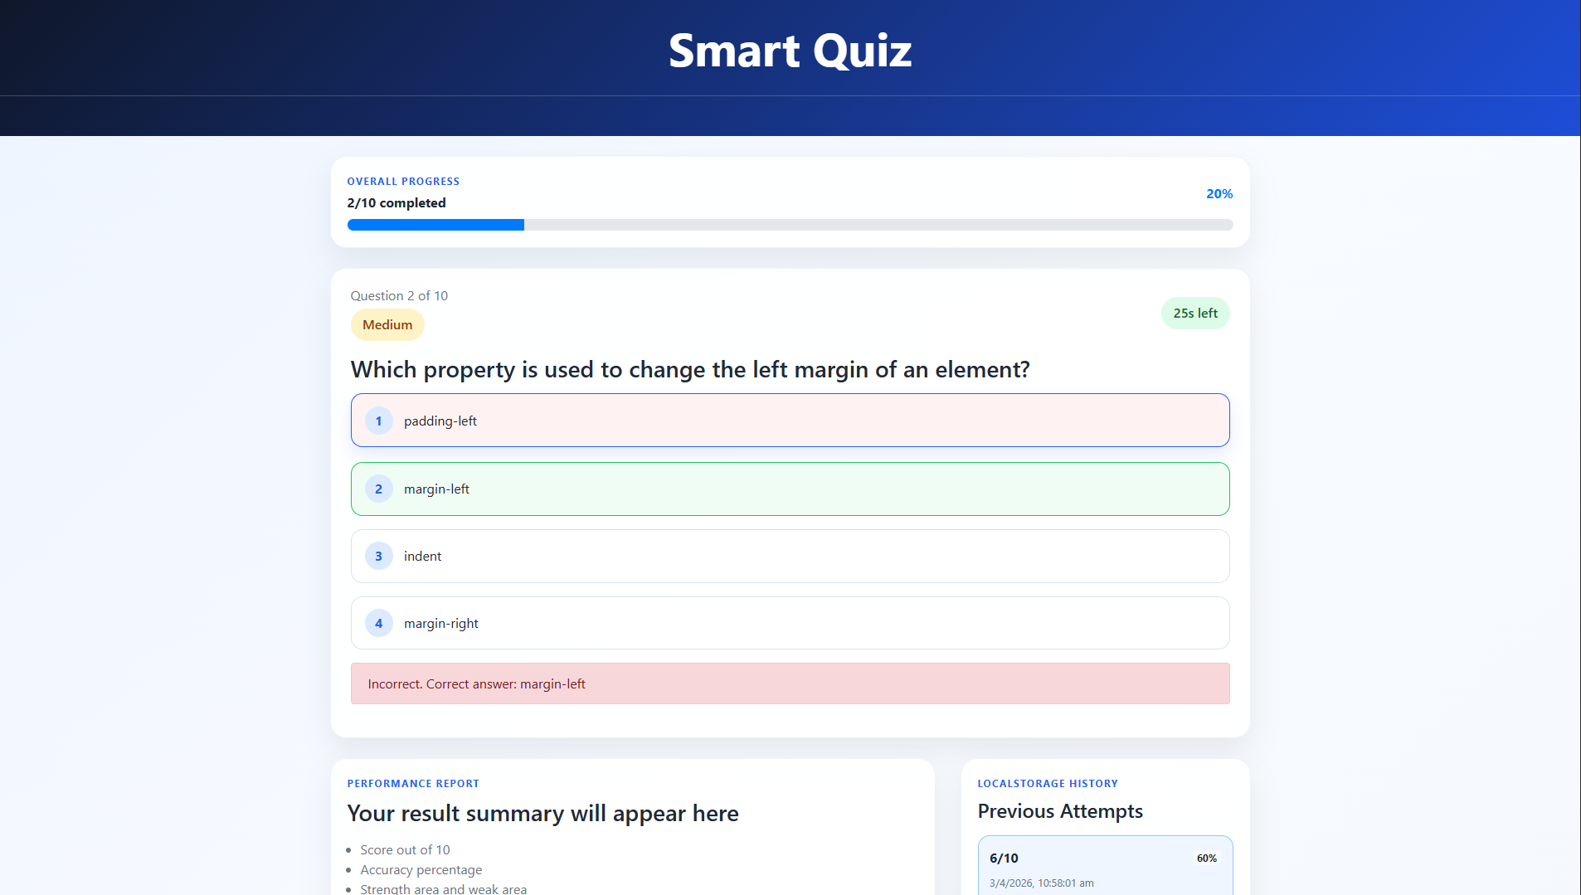

The difficulty increases after a correct answer
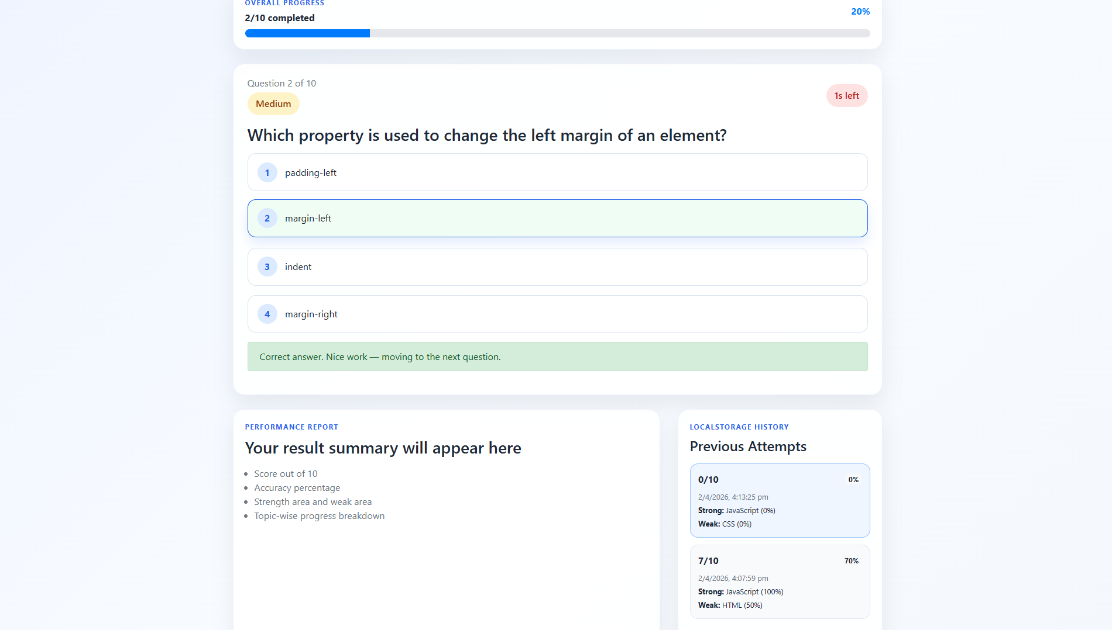

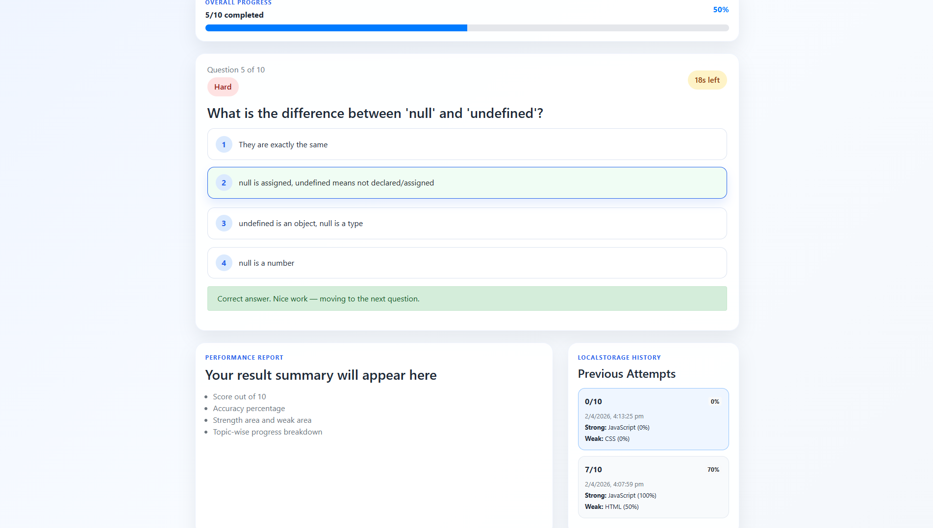

The result page
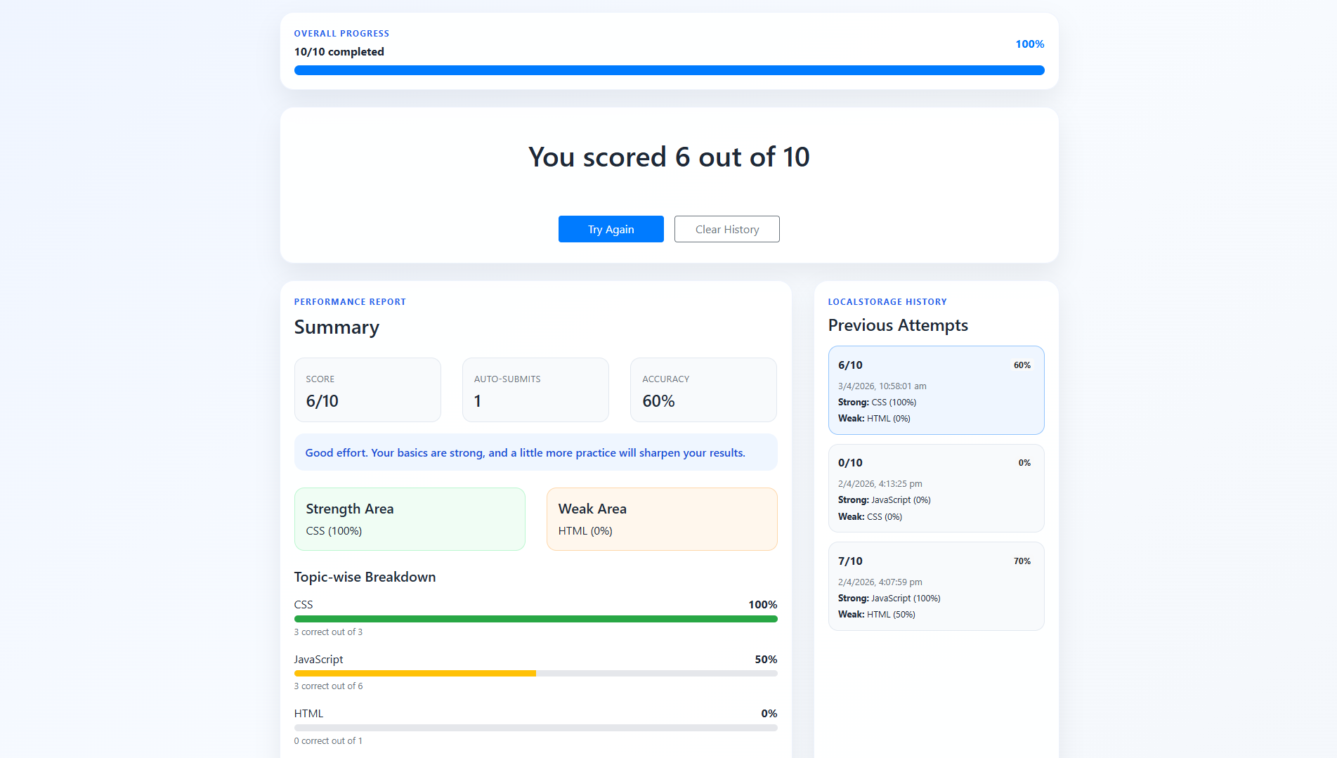

The Data Structure behind the dynamic Quiz
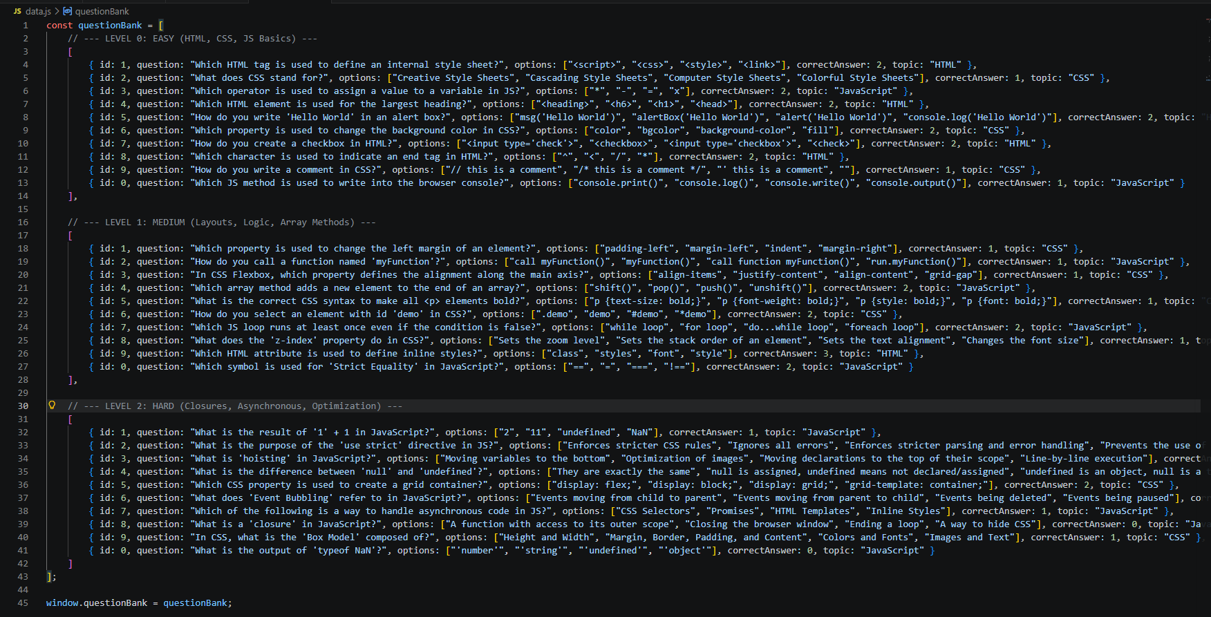

The logic behind showing a feedback per quiz question and analyzing the next difficulty level
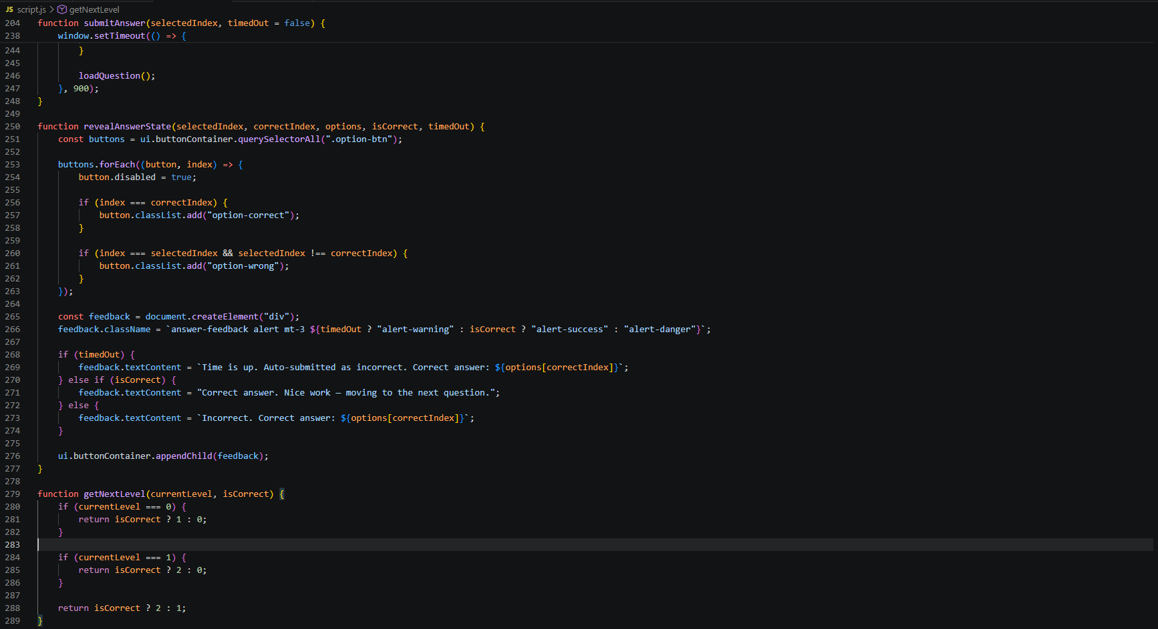

01/04
Problem 1

Available APIs:
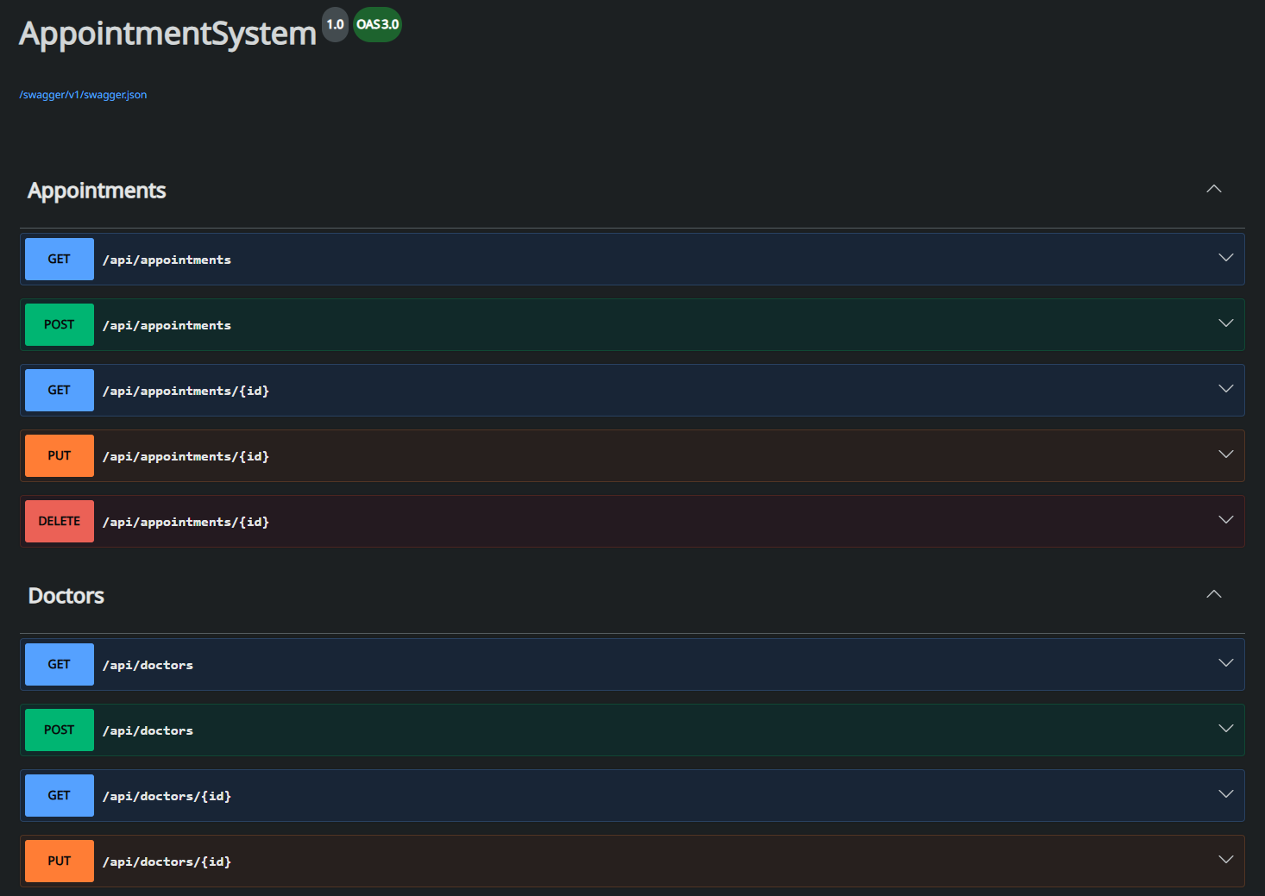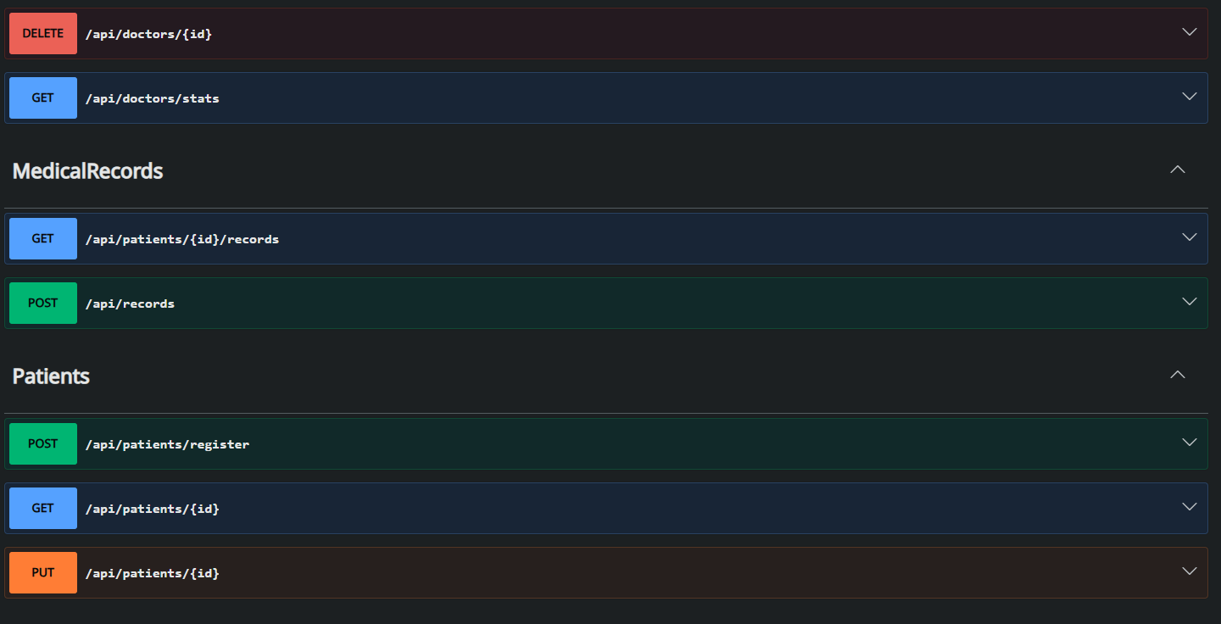

Schemas:
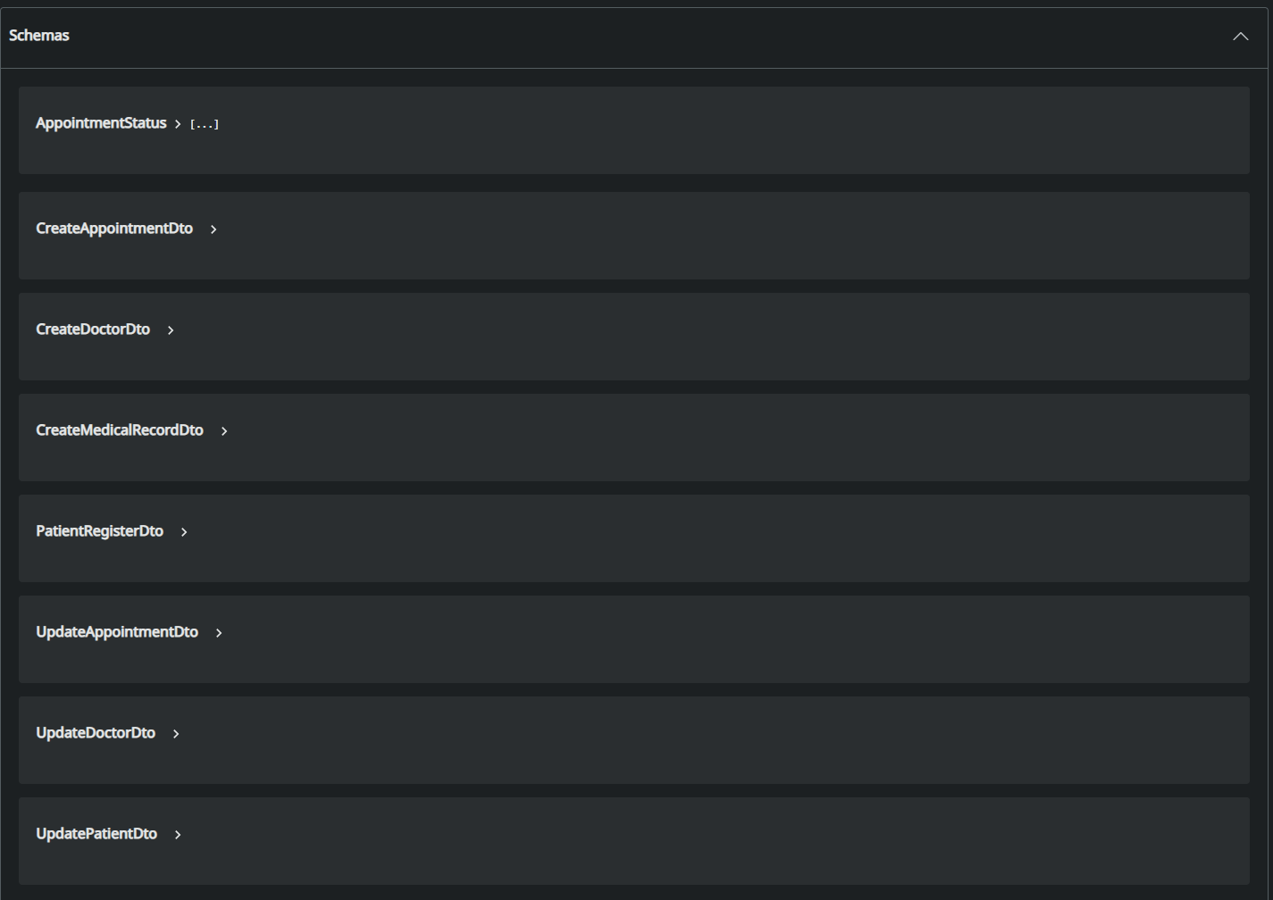

Register new patient
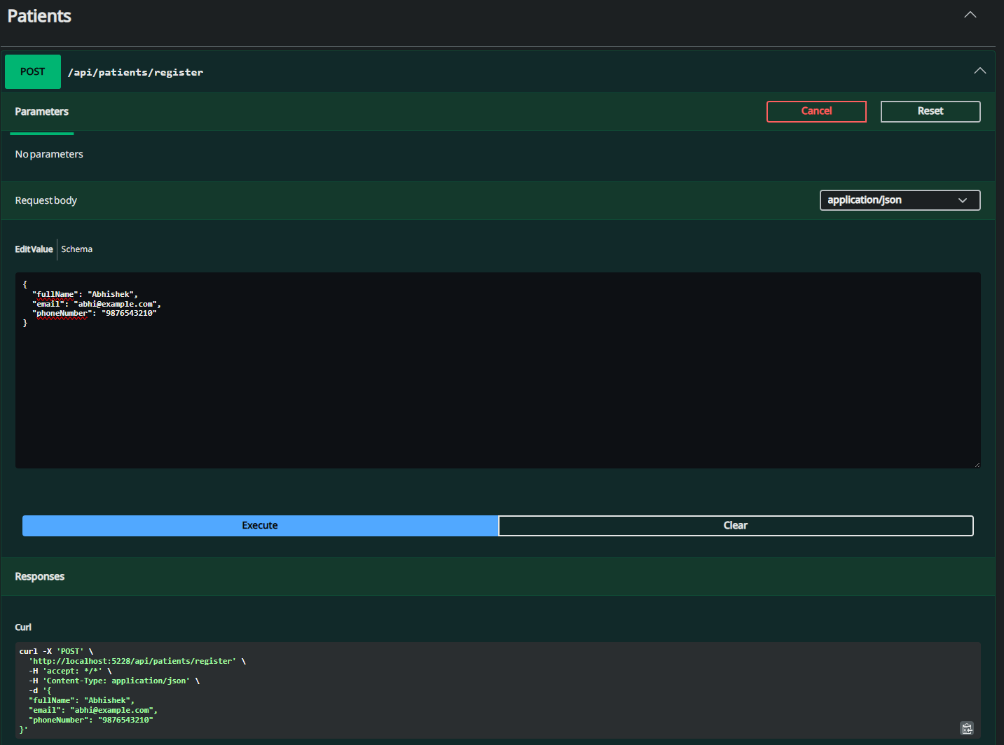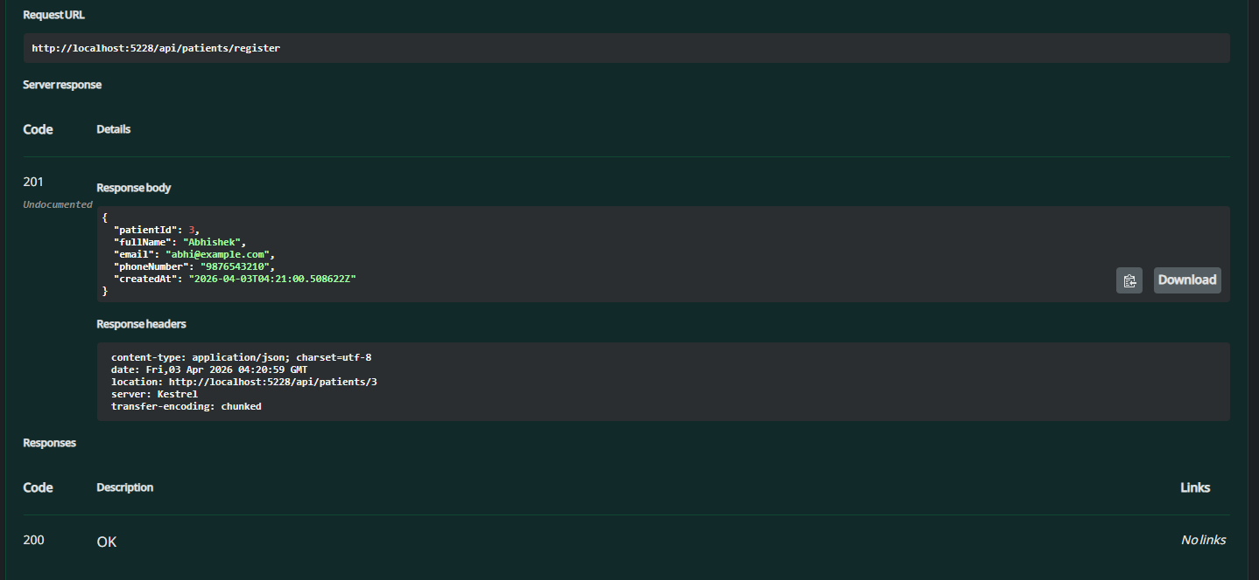

Get patient details
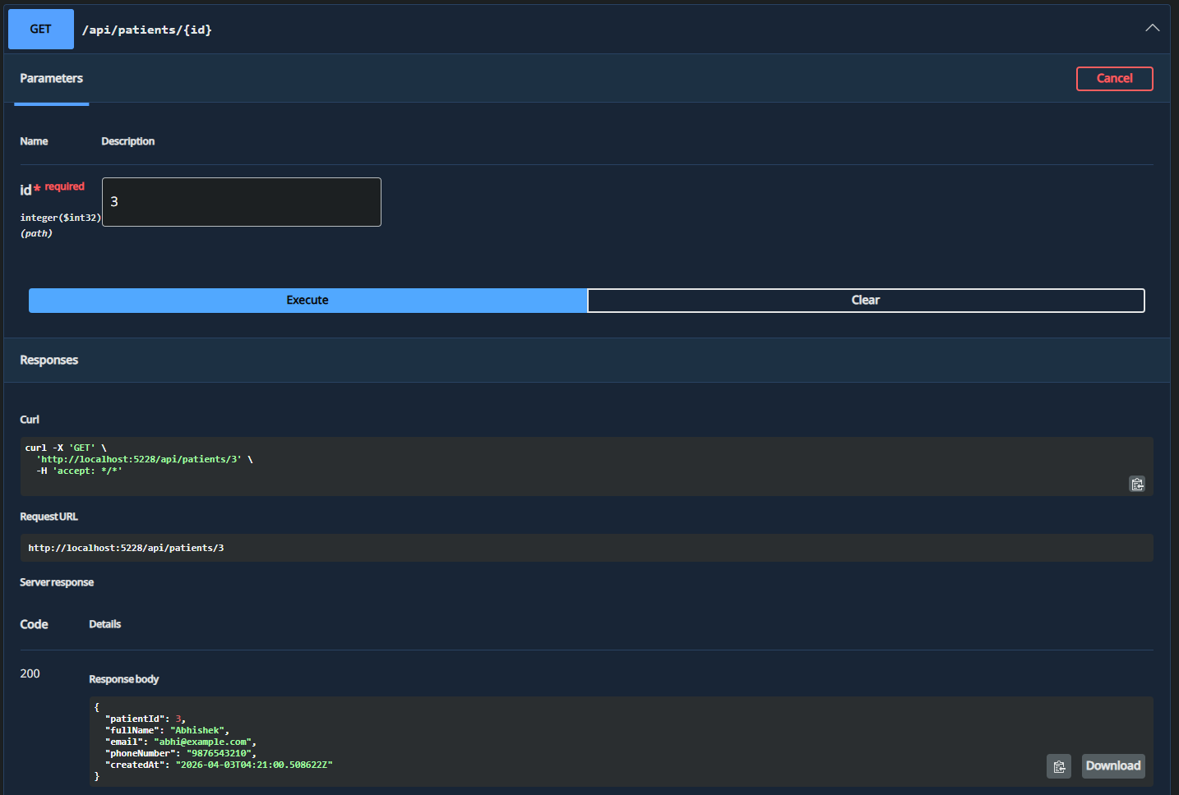

Adding doctor
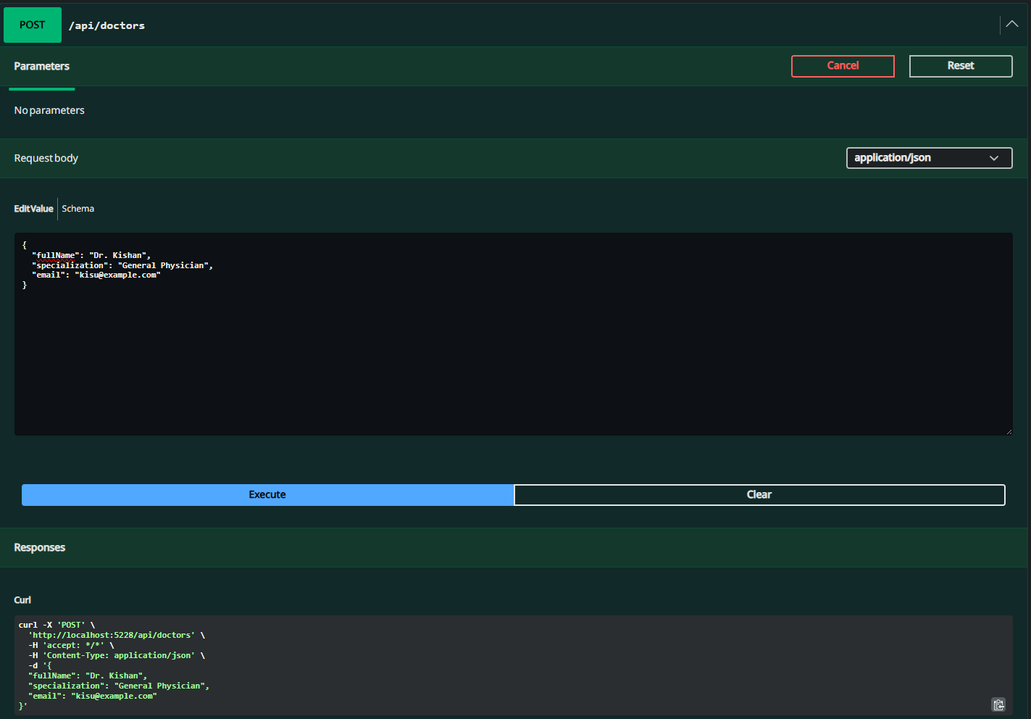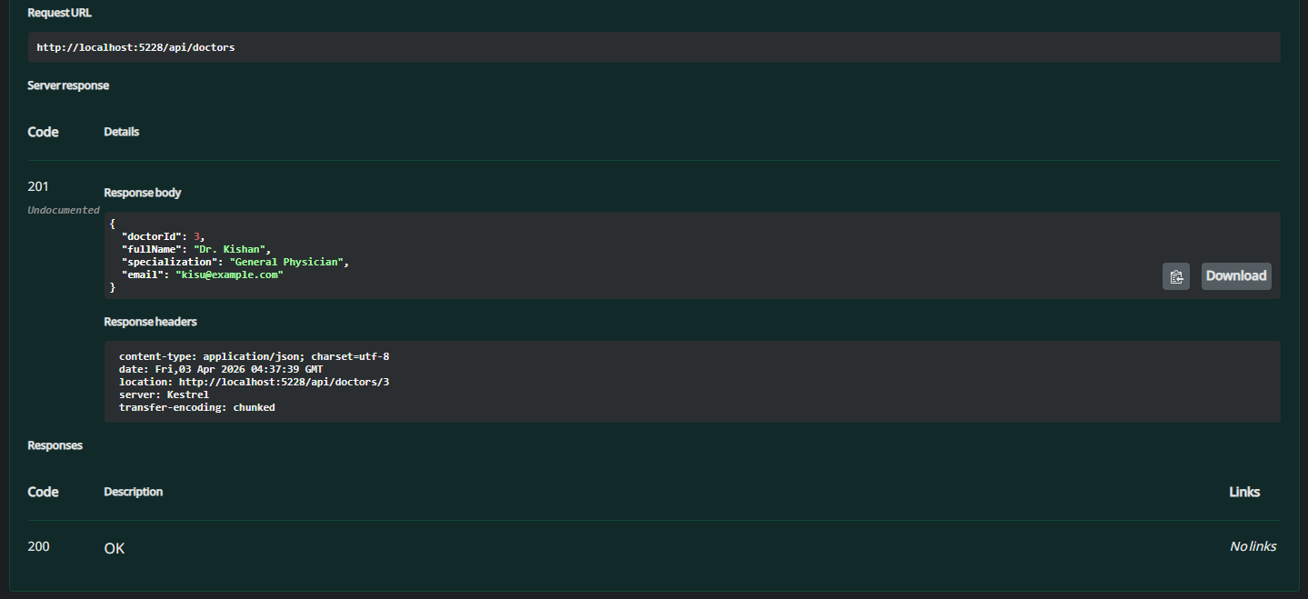

Viewing all doctors
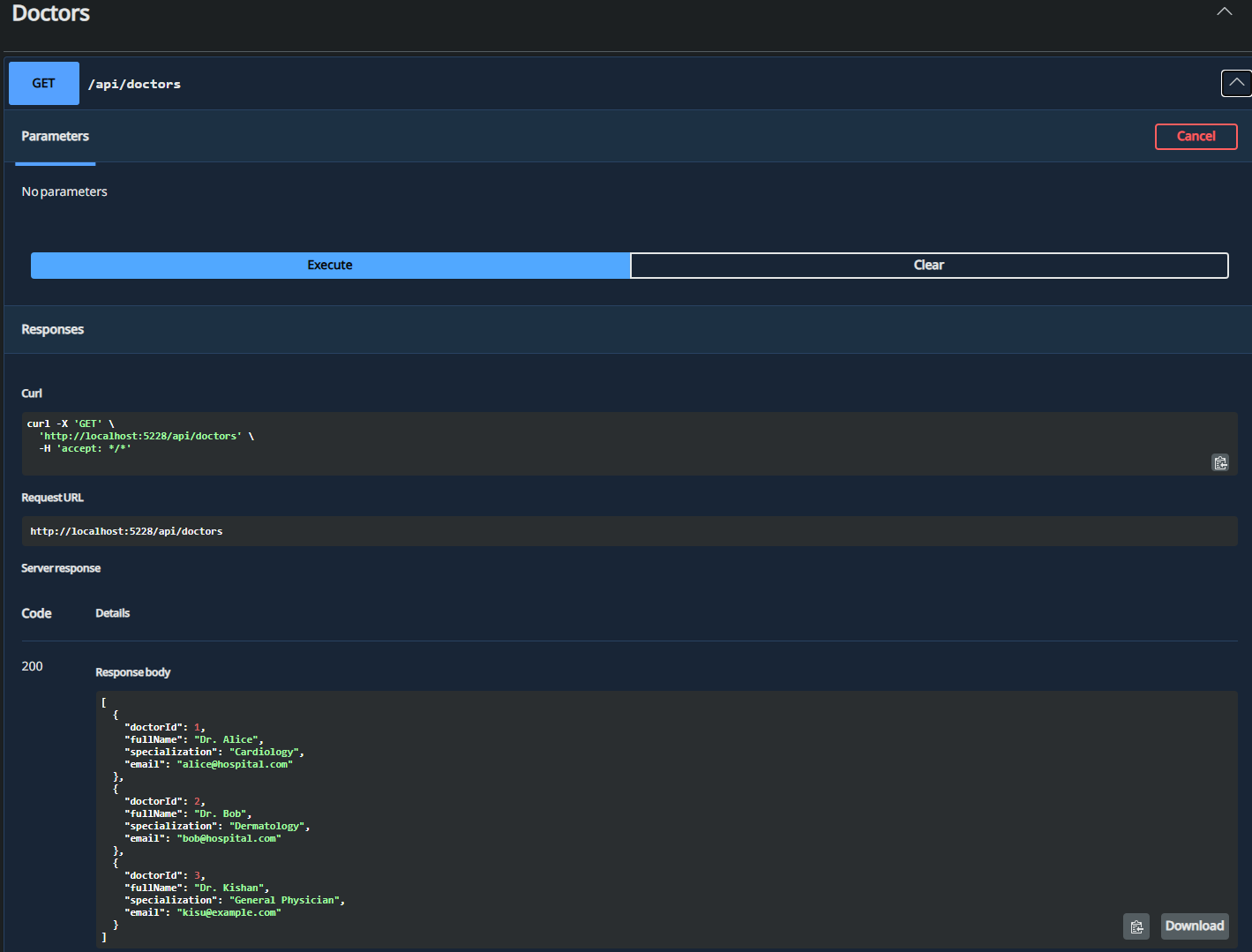

Booking Appointment
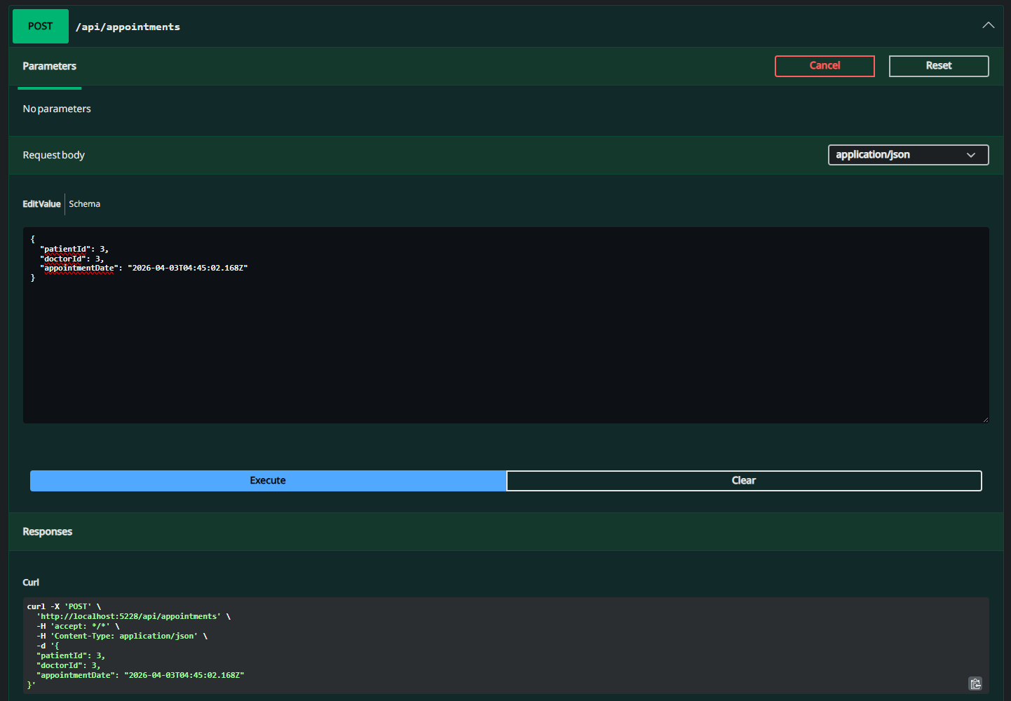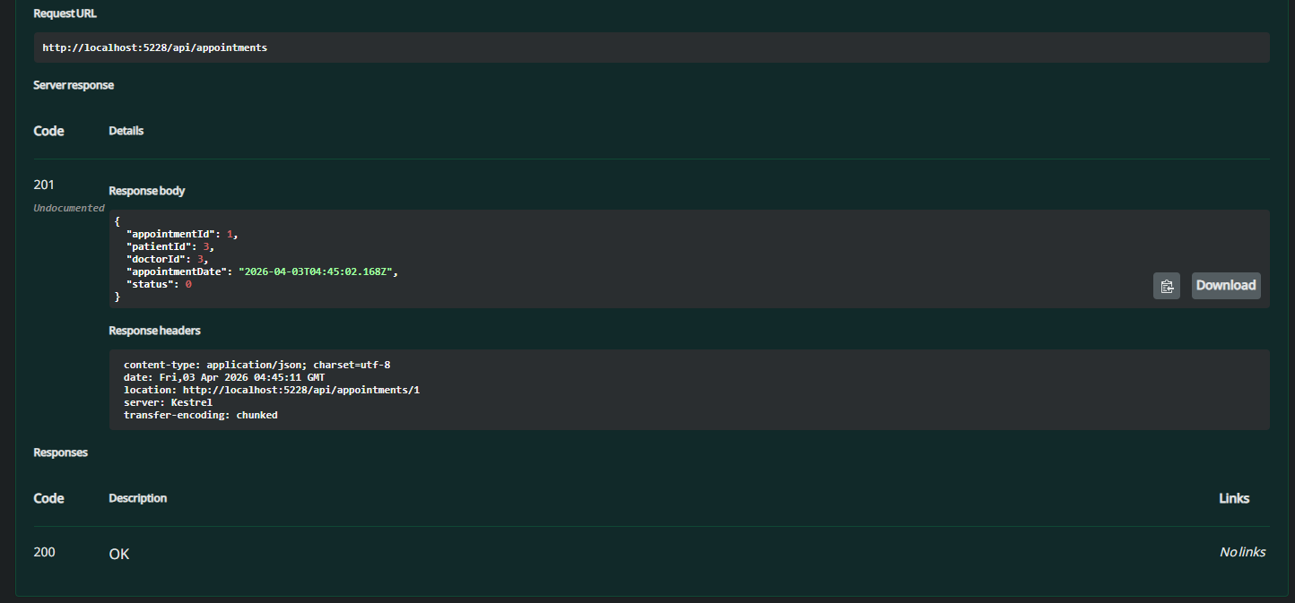

View all appointments
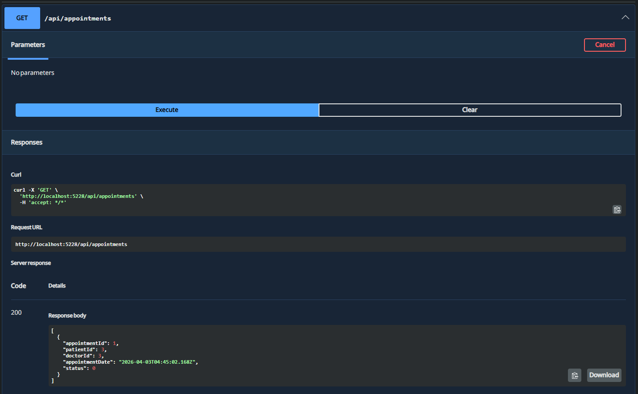

Doctor stat after booking an appointment
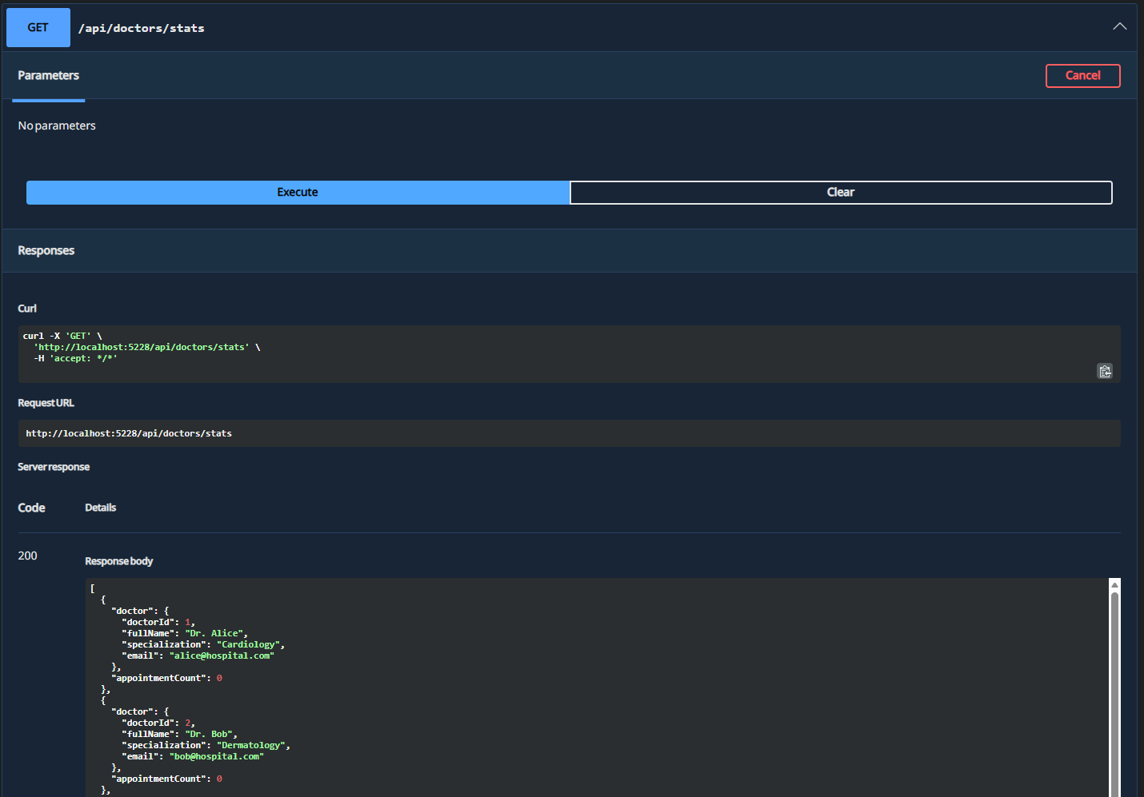
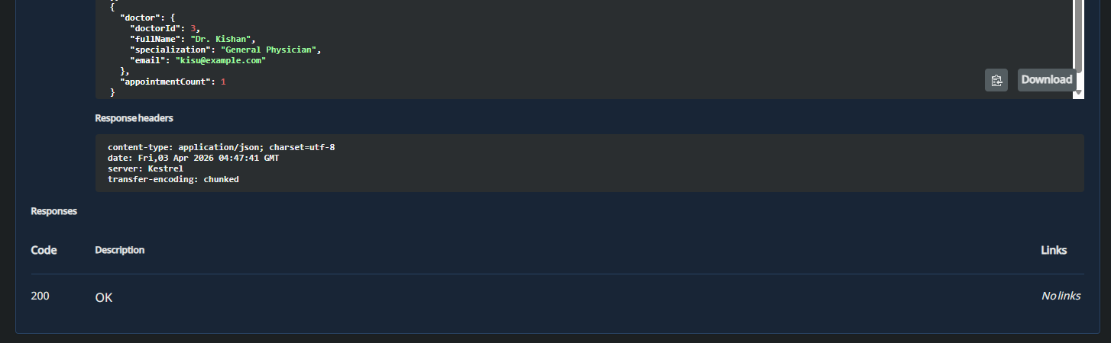

Adding Medical Record
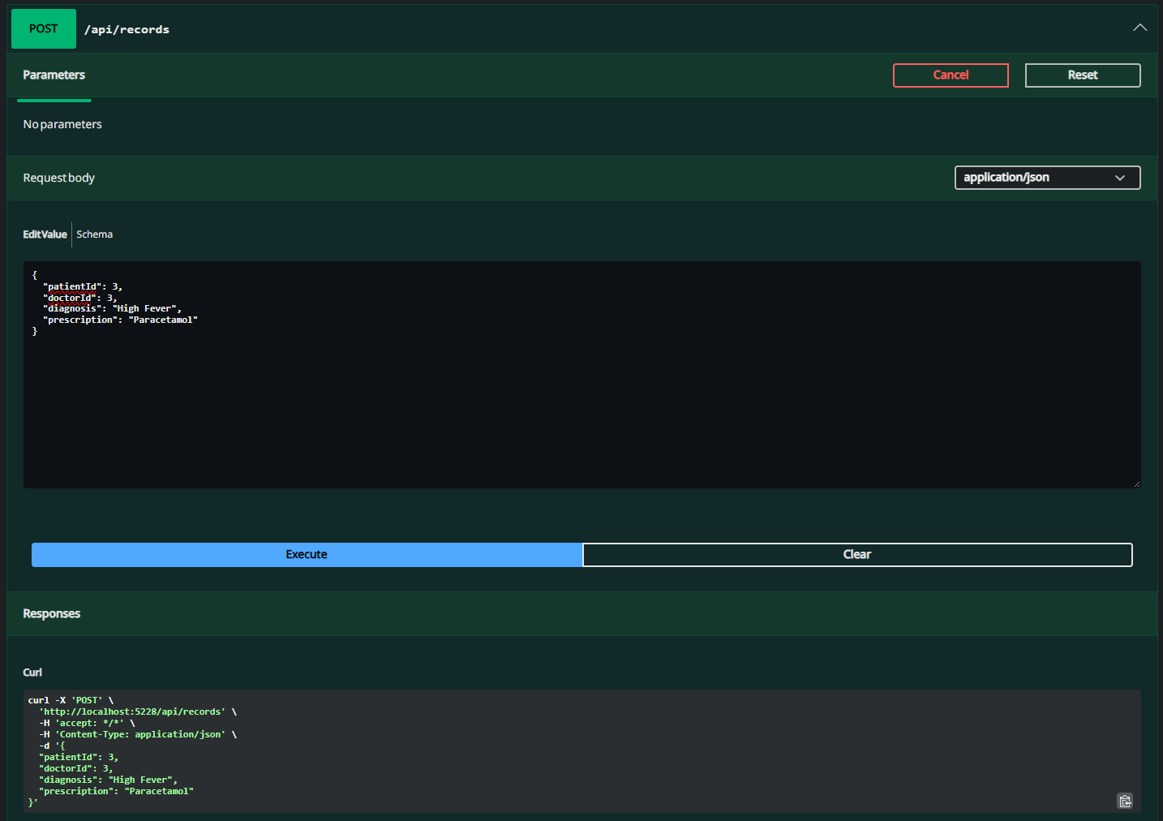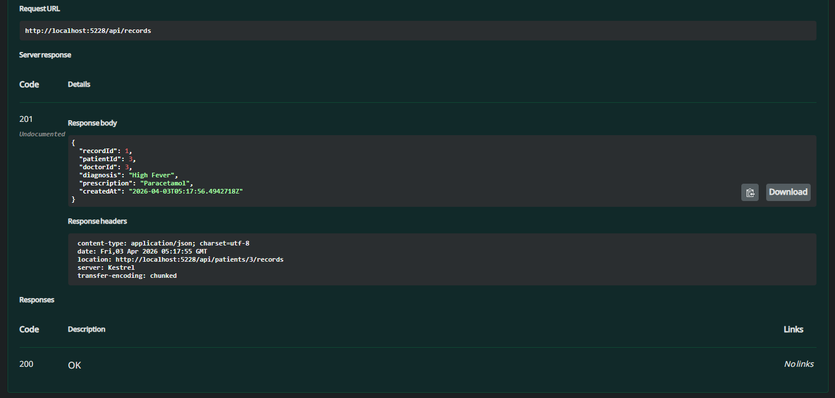

Viewing Medical Records
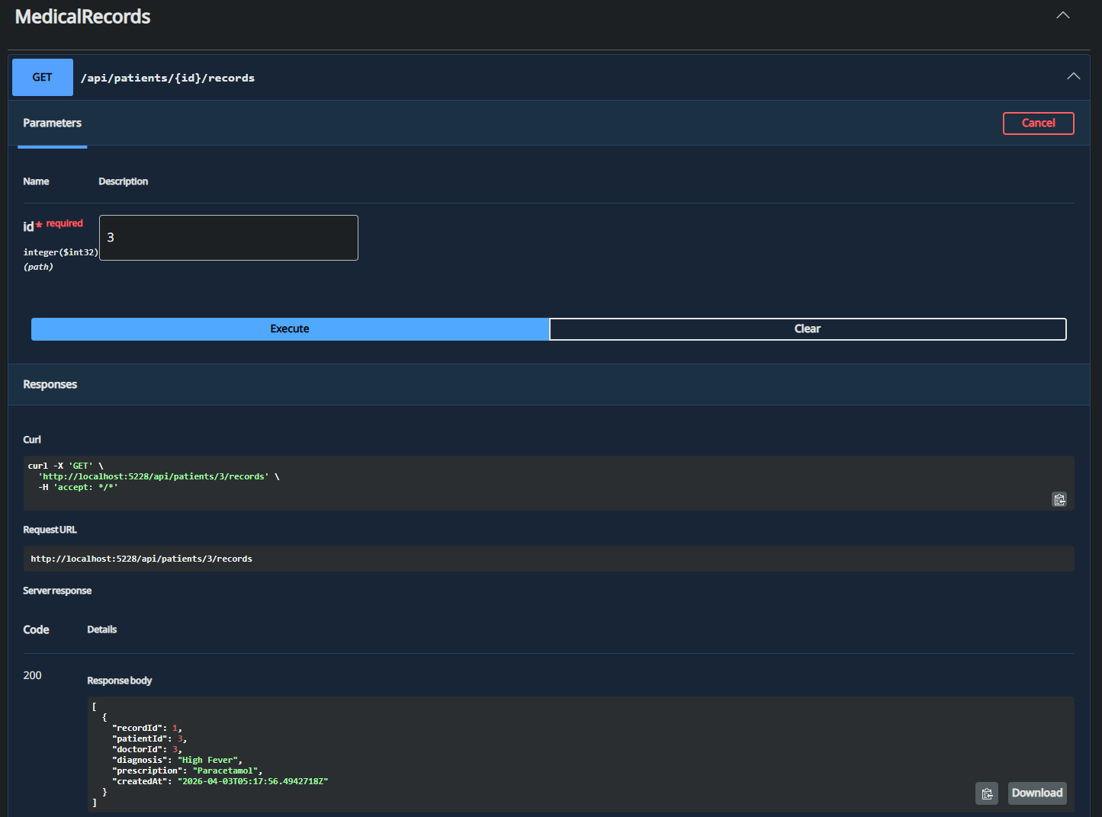

03/04
Problem 1

Program.cs
using Microsoft.AspNetCore.Authentication.JwtBearer;
using Microsoft.IdentityModel.Tokens;
using System.IdentityModel.Tokens.Jwt;
using System.Security.Claims;
using System.Text;
using Microsoft.Extensions.Logging;

var builder = WebApplication.CreateBuilder(args);

// Add services to the container.
// Learn more about configuring OpenAPI at https://aka.ms/aspnet/openapi
builder.Services.AddOpenApi();

// Add JWT Authentication
builder.Services.AddAuthentication(options =>
{
options.DefaultAuthenticateScheme = JwtBearerDefaults.AuthenticationScheme;
options.DefaultChallengeScheme = JwtBearerDefaults.AuthenticationScheme;
})
.AddJwtBearer(options =>
{
options.TokenValidationParameters = new TokenValidationParameters
{
ValidateIssuer = true,
ValidateAudience = true,
ValidateLifetime = true,
ValidateIssuerSigningKey = true,
ValidIssuer = builder.Configuration["Jwt:Issuer"],
ValidAudience = builder.Configuration["Jwt:Audience"],
IssuerSigningKey = new SymmetricSecurityKey(Encoding.UTF8.GetBytes(builder.Configuration["Jwt:Key"]!)),
ClockSkew = TimeSpan.FromMinutes(10), // Increased clock skew to 10 minutes to prevent random 401s due to time differences
RequireExpirationTime = true,
ValidateActor = false // Not using actors in this scenario
};

// Handle token validation events for debugging random 401s
options.Events = new JwtBearerEvents
{
OnAuthenticationFailed = context =>
{
var logger = context.HttpContext.RequestServices.GetRequiredService<ILogger<Program>>();
logger.LogWarning($"JWT Authentication failed: {context.Exception.Message}");
if (context.Exception is SecurityTokenExpiredException)
{
logger.LogWarning("Token has expired");
}
else if (context.Exception is SecurityTokenInvalidIssuerException)
{
logger.LogWarning("Invalid token issuer");
}
else if (context.Exception is SecurityTokenInvalidAudienceException)
{
logger.LogWarning("Invalid token audience");
}
else if (context.Exception is SecurityTokenSignatureKeyNotFoundException)
{
logger.LogWarning("Invalid token signature");
}
return Task.CompletedTask;
},
OnTokenValidated = context =>
{
var logger = context.HttpContext.RequestServices.GetRequiredService<ILogger<Program>>();
var claims = context.Principal?.Claims;
var userId = claims?.FirstOrDefault(c => c.Type == ClaimTypes.NameIdentifier)?.Value;
var expiry = claims?.FirstOrDefault(c => c.Type == JwtRegisteredClaimNames.Exp)?.Value;
logger.LogInformation($"JWT Token validated successfully for UserId: {userId}, Expires: {expiry}");
return Task.CompletedTask;
},
OnChallenge = context =>
{
var logger = context.HttpContext.RequestServices.GetRequiredService<ILogger<Program>>();
logger.LogWarning($"JWT Challenge triggered: {context.Error}, {context.ErrorDescription}");
return Task.CompletedTask;
}
};
});

builder.Services.AddAuthorization();

var app = builder.Build();

// Configure the HTTP request pipeline.
if (app.Environment.IsDevelopment())
{
app.MapOpenApi();
}

app.UseHttpsRedirection();

app.UseAuthentication();
app.UseAuthorization();

var summaries = new[]
{
"Freezing", "Bracing", "Chilly", "Cool", "Mild", "Warm", "Balmy", "Hot", "Sweltering", "Scorching"
};

// Login endpoint
app.MapPost("/api/auth/login", (LoginRequest request, IConfiguration config) =>
{
// Simple authentication - in real app, validate against database
if (request.Username == "admin" && request.Password == "password")
{
var jwtKey = config["Jwt:Key"]!;
var issuer = config["Jwt:Issuer"]!;
var audience = config["Jwt:Audience"]!;
var expiryMinutes = int.Parse(config["Jwt:ExpiryMinutes"]!);

var claims = new[]
{
new Claim(ClaimTypes.NameIdentifier, "1"), // UserId
new Claim(ClaimTypes.Name, request.Username),
new Claim(ClaimTypes.Role, "Admin"), // Role
new Claim(JwtRegisteredClaimNames.Jti, Guid.NewGuid().ToString())
};

var key = new SymmetricSecurityKey(Encoding.UTF8.GetBytes(jwtKey));
var creds = new SigningCredentials(key, SecurityAlgorithms.HmacSha256);

var token = new JwtSecurityToken(
issuer: issuer,
audience: audience,
claims: claims,
expires: DateTime.UtcNow.AddMinutes(expiryMinutes), // Use UTC consistently
notBefore: DateTime.UtcNow, // Token is valid immediately
signingCredentials: creds
);

var jwtToken = new JwtSecurityTokenHandler().WriteToken(token);
var refreshToken = Guid.NewGuid().ToString(); // In real app, store this securely

return Results.Ok(new LoginResponse(jwtToken, refreshToken, token.ValidTo));
}

return Results.Unauthorized();
});

// Refresh token endpoint
app.MapPost("/api/auth/refresh", (RefreshTokenRequest request, IConfiguration config) =>
{
// In real app, validate refresh token from database
// For demo, just generate new token
var jwtKey = config["Jwt:Key"]!;
var issuer = config["Jwt:Issuer"]!;
var audience = config["Jwt:Audience"]!;
var expiryMinutes = int.Parse(config["Jwt:ExpiryMinutes"]!);

var claims = new[]
{
new Claim(ClaimTypes.NameIdentifier, "1"),
new Claim(ClaimTypes.Name, "admin"),
new Claim(ClaimTypes.Role, "Admin"),
new Claim(JwtRegisteredClaimNames.Jti, Guid.NewGuid().ToString())
};

var key = new SymmetricSecurityKey(Encoding.UTF8.GetBytes(jwtKey));
var creds = new SigningCredentials(key, SecurityAlgorithms.HmacSha256);

var token = new JwtSecurityToken(
issuer: issuer,
audience: audience,
claims: claims,
expires: DateTime.UtcNow.AddMinutes(expiryMinutes),
notBefore: DateTime.UtcNow,
signingCredentials: creds
);

var jwtToken = new JwtSecurityTokenHandler().WriteToken(token);
var refreshToken = Guid.NewGuid().ToString();

return Results.Ok(new LoginResponse(jwtToken, refreshToken, token.ValidTo));
});

// Protected weather forecast endpoint
app.MapGet("/weatherforecast", () =>
{
var forecast = Enumerable.Range(1, 5).Select(index =>
new WeatherForecast
(
DateOnly.FromDateTime(DateTime.Now.AddDays(index)),
Random.Shared.Next(-20, 55),
summaries[Random.Shared.Next(summaries.Length)]
))
.ToArray();
return forecast;
})
.WithName("GetWeatherForecast")
.RequireAuthorization(); // Make it protected

// Another protected endpoint
app.MapGet("/api/protected", (ClaimsPrincipal user) =>
{
var userId = user.FindFirst(ClaimTypes.NameIdentifier)?.Value;
var role = user.FindFirst(ClaimTypes.Role)?.Value;
var username = user.FindFirst(ClaimTypes.Name)?.Value;

return Results.Ok(new
{
Message = "This is a protected endpoint",
UserId = userId,
Username = username,
Role = role,
Timestamp = DateTime.UtcNow
});
}).RequireAuthorization();

app.Run();

// Models
record LoginRequest(string Username, string Password);
record RefreshTokenRequest(string RefreshToken);
record LoginResponse(string Token, string RefreshToken, DateTime ExpiresAt);
record WeatherForecast(DateOnly Date, int TemperatureC, string? Summary)
{
public int TemperatureF => 32 + (int)(TemperatureC / 0.5556);
}

Problem 2
Program.cs
using ApiRateLimiting.RateLimiting;

var builder = WebApplication.CreateBuilder(args);

// Add services to the container.
// Learn more about configuring OpenAPI at https://aka.ms/aspnet/openapi
builder.Services.AddCustomRateLimiting(builder.Configuration);
builder.Services.AddOpenApi();

var app = builder.Build();

// Configure the HTTP request pipeline.
if (app.Environment.IsDevelopment())
{
app.MapOpenApi();
}

app.UseHttpsRedirection();
app.UseCustomRateLimiting();

var summaries = new[]
{
"Freezing", "Bracing", "Chilly", "Cool", "Mild", "Warm", "Balmy", "Hot", "Sweltering", "Scorching"
};

app.MapGet("/weatherforecast", () =>
{
var forecast = Enumerable.Range(1, 5).Select(index =>
new WeatherForecast
(
DateOnly.FromDateTime(DateTime.Now.AddDays(index)),
Random.Shared.Next(-20, 55),
summaries[Random.Shared.Next(summaries.Length)]
))
.ToArray();
return forecast;
})
.WithName("GetWeatherForecast");

app.Run();

record WeatherForecast(DateOnly Date, int TemperatureC, string? Summary)
{
public int TemperatureF => 32 + (int)(TemperatureC / 0.5556);
}

IRateLimiter.cs
namespace ApiRateLimiting.RateLimiting;

public interface IRequestRateLimiter
{
Task<bool> IsRequestAllowedAsync(string clientId);
}

RateLimitingExtensions.cs
using Microsoft.AspNetCore.Builder;
using Microsoft.Extensions.Configuration;
using Microsoft.Extensions.DependencyInjection;
using Microsoft.Extensions.Options;

namespace ApiRateLimiting.RateLimiting;

public static class RateLimitingExtensions
{
public static IServiceCollection AddCustomRateLimiting(this IServiceCollection services, IConfiguration configuration)
{
services.Configure<RateLimitOptions>(configuration.GetSection("RateLimiting"));
services.AddSingleton(sp => sp.GetRequiredService<IOptions<RateLimitOptions>>().Value);
services.AddSingleton<IRequestRateLimiter>(sp =>
{
var options = sp.GetRequiredService<RateLimitOptions>();
return options.UseRedis
? new RedisSlidingWindowRateLimiter(options)
: new InMemorySlidingWindowRateLimiter(options);
});

return services;
}

public static IApplicationBuilder UseCustomRateLimiting(this IApplicationBuilder app)
{
return app.UseMiddleware<RateLimitingMiddleware>();
}
}

RateLimitingMiddleware.cs
using Microsoft.AspNetCore.Http;
using Microsoft.Extensions.Logging;

namespace ApiRateLimiting.RateLimiting;

public sealed class RateLimitingMiddleware
{
private readonly RequestDelegate _next;
private readonly IRequestRateLimiter _rateLimiter;
private readonly ILogger<RateLimitingMiddleware> _logger;
private readonly RateLimitOptions _options;

public RateLimitingMiddleware(RequestDelegate next, IRequestRateLimiter rateLimiter, ILogger<RateLimitingMiddleware> logger, RateLimitOptions options)
{
_next = next;
_rateLimiter = rateLimiter;
_logger = logger;
_options = options;
}

public async Task InvokeAsync(HttpContext context)
{
var clientId = GetClientId(context);
if (!await _rateLimiter.IsRequestAllowedAsync(clientId))
{
_logger.LogWarning("Rate limit exceeded for client {ClientId}", clientId);
context.Response.StatusCode = StatusCodes.Status429TooManyRequests;
context.Response.ContentType = "application/json";
await context.Response.WriteAsJsonAsync(new
{
error = "Rate limit exceeded. Max 5 requests per 10 seconds.",
limit = _options.Limit,
windowSeconds = _options.WindowSeconds
});
return;
}

await _next(context);
}

private string GetClientId(HttpContext context)
{
var forwardedHeader = _options.ClientIpHeader;
var clientId = context.User?.Identity?.IsAuthenticated == true ? context.User.Identity?.Name : null;
if (!string.IsNullOrEmpty(clientId))
{
return $"user:{clientId}";
}

if (context.Request.Headers.TryGetValue(forwardedHeader, out var headerValue) && headerValue.Count > 0)
{
var forwardedIp = headerValue.ToString().Split(',')[0].Trim();
if (!string.IsNullOrEmpty(forwardedIp))
{
return $"ip:{forwardedIp}";
}
}

var remoteIp = context.Connection.RemoteIpAddress?.ToString() ?? "unknown";
return $"ip:{remoteIp}";
}
}

RateLimitOptions.cs
namespace ApiRateLimiting.RateLimiting;

public sealed class RateLimitOptions
{
public int Limit { get; init; } = 5;
public int WindowSeconds { get; init; } = 10;
public bool UseRedis { get; init; }
public string RedisConnectionString { get; init; } = "localhost:6379";
public string ClientIpHeader { get; init; } = "X-Forwarded-For";
}

RadisRateLimiter.cs
using StackExchange.Redis;

namespace ApiRateLimiting.RateLimiting;

public sealed class RedisSlidingWindowRateLimiter : IRequestRateLimiter, IDisposable
{
private readonly IDatabase _database;
private readonly TimeSpan _window;
private readonly int _limit;
private readonly ConnectionMultiplexer _redis;
private readonly string _keyPrefix = "rate_limiting";

public RedisSlidingWindowRateLimiter(RateLimitOptions options)
{
_limit = options.Limit;
_window = TimeSpan.FromSeconds(options.WindowSeconds);
_redis = ConnectionMultiplexer.Connect(options.RedisConnectionString);
_database = _redis.GetDatabase();
}

public async Task<bool> IsRequestAllowedAsync(string clientId)
{
var key = GetRedisKey(clientId);
var now = DateTimeOffset.UtcNow.ToUnixTimeMilliseconds();
var windowStart = now - (long)_window.TotalMilliseconds;
var expiry = (long)_window.TotalMilliseconds + 1000;

const string script = @"
redis.call('ZREMRANGEBYSCORE', KEYS[1], 0, ARGV[1])
redis.call('ZADD', KEYS[1], ARGV[2], ARGV[2])
redis.call('PEXPIRE', KEYS[1], ARGV[3])
local count = redis.call('ZCARD', KEYS[1])
return count
";

var result = (long)await _database.ScriptEvaluateAsync(
script,
new RedisKey[] { key },
new RedisValue[] { windowStart, now, expiry });

return result <= _limit;
}

private string GetRedisKey(string clientId) => $"{_keyPrefix}:{clientId}";

public void Dispose() => _redis.Dispose();
}

SlidingWindowRateLimiter.cs
using System.Collections.Concurrent;

namespace ApiRateLimiting.RateLimiting;

public sealed class InMemorySlidingWindowRateLimiter : IRequestRateLimiter
{
private readonly int _limit;
private readonly TimeSpan _window;
private readonly ConcurrentDictionary<string, SlidingWindow> _windows = new();

public InMemorySlidingWindowRateLimiter(RateLimitOptions options)
{
_limit = options.Limit;
_window = TimeSpan.FromSeconds(options.WindowSeconds);
}

public Task<bool> IsRequestAllowedAsync(string clientId)
{
var window = _windows.GetOrAdd(clientId, _ => new SlidingWindow(_window));
return Task.FromResult(window.TryAcquire(_limit));
}

private sealed class SlidingWindow
{
private readonly TimeSpan _window;
private readonly Queue<DateTime> _timestamps = new();
private readonly object _sync = new();

public SlidingWindow(TimeSpan window)
{
_window = window;
}

public bool TryAcquire(int limit)
{
var now = DateTime.UtcNow;
lock (_sync)
{
while (_timestamps.Count > 0 && now - _timestamps.Peek() >= _window)
{
_timestamps.Dequeue();
}

if (_timestamps.Count >= limit)
{
return false;
}

_timestamps.Enqueue(now);
return true;
}
}
}
}

Problem 3

Program.cs
using System.Text;

var builder = WebApplication.CreateBuilder(args);
var app = builder.Build();

app.MapGet("/demo/deadlock", () => Results.Text(RunDeadlockScenario(), "text/plain"));
app.MapGet("/demo/fixed", () => Results.Text(RunFixedScenarios(), "text/plain"));
app.MapGet("/demo/explanation", () => Results.Text(GetDeadlockExplanation(), "text/plain"));

app.MapGet("/weatherforecast", () =>
{
var summaries = new[]
{
"Freezing", "Bracing", "Chilly", "Cool", "Mild", "Warm", "Balmy", "Hot", "Sweltering", "Scorching"
};

var forecast = Enumerable.Range(1, 5).Select(index =>
new WeatherForecast
(
DateOnly.FromDateTime(DateTime.Now.AddDays(index)),
Random.Shared.Next(-20, 55),
summaries[Random.Shared.Next(summaries.Length)]
))
.ToArray();
return forecast;
})
.WithName("GetWeatherForecast");

app.Run();

string RunDeadlockScenario()
{
var resourceA = new LockResource("Resource A");
var resourceB = new LockResource("Resource B");
var result = new StringBuilder();

result.AppendLine("Deadlock scenario: two threads acquire two resources in opposite order.");
result.AppendLine("This creates circular wait, so the threads can deadlock.");

var thread1 = new Thread(() => AcquireResources("Thread 1", resourceA, resourceB, result)) { IsBackground = true };
var thread2 = new Thread(() => AcquireResources("Thread 2", resourceB, resourceA, result)) { IsBackground = true };

thread1.Start();
thread2.Start();

var timeoutMs = 2500;
var completed1 = thread1.Join(timeoutMs);
var completed2 = thread2.Join(timeoutMs);

result.AppendLine();
if (!completed1 || !completed2)
{
result.AppendLine("Deadlock detected: one or both threads failed to complete within the timeout.");
result.AppendLine("Four deadlock conditions present:");
result.AppendLine("1. Mutual exclusion (resources are locked exclusively).");
result.AppendLine("2. Hold and wait (threads hold one lock while waiting for another).");
result.AppendLine("3. No preemption (locks cannot be forcibly taken away).");
result.AppendLine("4. Circular wait (Thread 1 waits for Resource B while Thread 2 waits for Resource A).");
}
else
{
result.AppendLine("No deadlock detected, but this scenario is designed to demonstrate a deadlock.");
}

return result.ToString();
}

string RunFixedScenarios()
{
var resourceA = new LockResource("Resource A");
var resourceB = new LockResource("Resource B");
var result = new StringBuilder();

result.AppendLine("Fixed scenario 1: consistent lock ordering prevents deadlock.");
result.AppendLine("Both threads acquire Resource A first, then Resource B.");
result.AppendLine(RunLockOrderingScenario(resourceA, resourceB));
result.AppendLine();
result.AppendLine("Fixed scenario 2: timeout handling prevents permanent deadlock.");
result.AppendLine(RunTimeoutScenario(resourceA, resourceB));

return result.ToString();
}

string RunLockOrderingScenario(LockResource resourceA, LockResource resourceB)
{
var result = new StringBuilder();

var thread1 = new Thread(() => AcquireResources("Thread 1", resourceA, resourceB, result)) { IsBackground = true };
var thread2 = new Thread(() => AcquireResources("Thread 2", resourceA, resourceB, result)) { IsBackground = true };

thread1.Start();
thread2.Start();

var timeoutMs = 5000;
var completed1 = thread1.Join(timeoutMs);
var completed2 = thread2.Join(timeoutMs);

if (completed1 && completed2)
{
result.AppendLine("Both threads completed successfully with lock ordering.");
}
else
{
result.AppendLine("Lock ordering scenario did not complete in time. This should not occur under normal conditions.");
}

return result.ToString();
}

string RunTimeoutScenario(LockResource resourceA, LockResource resourceB)
{
var result = new StringBuilder();

var thread1 = new Thread(() => AcquireResourcesWithTimeout("Thread 1", resourceA, resourceB, 2000, result)) { IsBackground = true };
var thread2 = new Thread(() => AcquireResourcesWithTimeout("Thread 2", resourceB, resourceA, 2000, result)) { IsBackground = true };

thread1.Start();
thread2.Start();

var timeoutMs = 7000;
var completed1 = thread1.Join(timeoutMs);
var completed2 = thread2.Join(timeoutMs);

if (completed1 && completed2)
{
result.AppendLine("Both threads completed with timeout handling enabled.");
}
else
{
result.AppendLine("Timeout scenario did not complete in time. One or more threads may still be waiting.");
}

return result.ToString();
}

void AcquireResources(string threadName, LockResource first, LockResource second, StringBuilder result)
{
result.AppendLine($"{threadName} trying to acquire {first.Name}.");
lock (first.Sync)
{
result.AppendLine($"{threadName} acquired {first.Name}.");
Thread.Sleep(200);
result.AppendLine($"{threadName} trying to acquire {second.Name}.");

lock (second.Sync)
{
result.AppendLine($"{threadName} acquired {second.Name}.");
Thread.Sleep(200);
result.AppendLine($"{threadName} finished work with both resources.");
}

result.AppendLine($"{threadName} released {second.Name}.");
}
result.AppendLine($"{threadName} released {first.Name}.");
}

void AcquireResourcesWithTimeout(string threadName, LockResource first, LockResource second, int timeoutMs, StringBuilder result)
{
result.AppendLine($"{threadName} trying to acquire {first.Name} with timeout {timeoutMs}ms.");
var acquiredFirst = false;
var acquiredSecond = false;

try
{
acquiredFirst = Monitor.TryEnter(first.Sync, timeoutMs);
if (!acquiredFirst)
{
result.AppendLine($"{threadName} timed out waiting for {first.Name}.");
return;
}

result.AppendLine($"{threadName} acquired {first.Name}.");
Thread.Sleep(200);
result.AppendLine($"{threadName} trying to acquire {second.Name} with timeout {timeoutMs}ms.");

acquiredSecond = Monitor.TryEnter(second.Sync, timeoutMs);
if (!acquiredSecond)
{
result.AppendLine($"{threadName} timed out waiting for {second.Name} and will release {first.Name}.");
return;
}

result.AppendLine($"{threadName} acquired {second.Name}.");
Thread.Sleep(200);
result.AppendLine($"{threadName} finished work with both resources.");
}
finally
{
if (acquiredSecond)
{
Monitor.Exit(second.Sync);
result.AppendLine($"{threadName} released {second.Name}.");
}

if (acquiredFirst)
{
Monitor.Exit(first.Sync);
result.AppendLine($"{threadName} released {first.Name}.");
}
}
}

string GetDeadlockExplanation()
{
return new StringBuilder()
.AppendLine("Why deadlock occurs:")
.AppendLine("- Mutual exclusion: resources are held by one thread at a time.")
.AppendLine("- Hold and wait: threads hold one resource while waiting for another.")
.AppendLine("- No preemption: locks cannot be forcibly taken away.")
.AppendLine("- Circular wait: each thread waits for a resource held by the other.")
.AppendLine()
.AppendLine("How to prevent:")
.AppendLine("- Lock ordering: always acquire locks in the same global order. This breaks circular wait.")
.AppendLine("- Timeout: use Monitor.TryEnter with a timeout and back off if the second lock cannot be acquired.")
.AppendLine()
.AppendLine("Trade-offs:")
.AppendLine("- Lock ordering is simple and reliable, but it can be hard to enforce in large systems and may reduce concurrency.")
.AppendLine("- Timeout handling avoids permanent deadlock, but it adds complexity and may require retry/backoff logic; it can also lead to starvation if not designed carefully.")
.ToString();
}

record LockResource(string Name)
{
public object Sync { get; } = new();
}

record WeatherForecast(DateOnly Date, int TemperatureC, string? Summary)
{
public int TemperatureF => 32 + (int)(TemperatureC / 0.5556);
}

Problem 4

Program.cs
using System.Collections.Generic;
using System.Diagnostics;

public class CustomHashMap<TKey, TValue> where TKey : notnull
{
private LinkedList<KeyValuePair<TKey, TValue>>[] buckets;
private int count;
private int capacity;
private const double LoadFactorThreshold = 0.75;

public CustomHashMap(int initialCapacity = 16)
{
capacity = initialCapacity;
buckets = new LinkedList<KeyValuePair<TKey, TValue>>[capacity];
for (int i = 0; i < capacity; i++)
{
buckets[i] = new LinkedList<KeyValuePair<TKey, TValue>>();
}
count = 0;
}

private int GetBucketIndex(TKey key)
{
int hash = key.GetHashCode();
// To avoid negative hash codes
hash = hash & 0x7FFFFFFF; // Make positive
return hash % capacity;
}

public void Add(TKey key, TValue value)
{
int index = GetBucketIndex(key);
var bucket = buckets[index];

// Check if key already exists
var node = bucket.First;
while (node != null)
{
if (EqualityComparer<TKey>.Default.Equals(node.Value.Key, key))
{
// Update value by removing and adding new
bucket.Remove(node);
bucket.AddLast(new KeyValuePair<TKey, TValue>(key, value));
return;
}
node = node.Next;
}

// Add new
bucket.AddLast(new KeyValuePair<TKey, TValue>(key, value));
count++;

// Check load factor
if ((double)count / capacity > LoadFactorThreshold)
{
Resize();
}
}

public TValue? Get(TKey key)
{
int index = GetBucketIndex(key);
var bucket = buckets[index];

var node = bucket.First;
while (node != null)
{
if (EqualityComparer<TKey>.Default.Equals(node.Value.Key, key))
{
return node.Value.Value;
}
node = node.Next;
}

throw new KeyNotFoundException("Key not found");
}

public bool Remove(TKey key)
{
int index = GetBucketIndex(key);
var bucket = buckets[index];

var node = bucket.First;
while (node != null)
{
if (EqualityComparer<TKey>.Default.Equals(node.Value.Key, key))
{
bucket.Remove(node);
count--;
return true;
}
node = node.Next;
}

return false;
}

private void Resize()
{
int newCapacity = capacity * 2;
var newBuckets = new LinkedList<KeyValuePair<TKey, TValue>>[newCapacity];
for (int i = 0; i < newCapacity; i++)
{
newBuckets[i] = new LinkedList<KeyValuePair<TKey, TValue>>();
}

// Rehash all entries
foreach (var bucket in buckets)
{
foreach (var pair in bucket)
{
int hash = pair.Key.GetHashCode() & 0x7FFFFFFF;
int newIndex = hash % newCapacity;
newBuckets[newIndex].AddLast(pair);
}
}

buckets = newBuckets;
capacity = newCapacity;
}

public int Count => count;
public int Capacity => capacity;
public double LoadFactor => (double)count / capacity;
}

class Program
{
static void Main(string[] args)
{
var hashMap = new CustomHashMap<string, int>();

// Test basic operations
hashMap.Add("key1", 1);
hashMap.Add("key2", 2);
Console.WriteLine($"Get key1: {hashMap.Get("key1")}");
Console.WriteLine($"Get key2: {hashMap.Get("key2")}");

hashMap.Add("key1", 10); // Update
Console.WriteLine($"Updated key1: {hashMap.Get("key1")}");

hashMap.Remove("key2");
try
{
hashMap.Get("key2");
}
catch (KeyNotFoundException)
{
Console.WriteLine("key2 removed successfully");
}

// Performance test
Console.WriteLine("Starting performance test...");
var stopwatch = Stopwatch.StartNew();
int numInserts = 100000;
for (int i = 0; i < numInserts; i++)
{
hashMap.Add($"key{i}", i);
}
stopwatch.Stop();
Console.WriteLine($"Inserted {numInserts} items in {stopwatch.ElapsedMilliseconds} ms");
Console.WriteLine($"Final count: {hashMap.Count}, Capacity: {hashMap.Capacity}, Load Factor: {hashMap.LoadFactor}");

// Test lookups
stopwatch.Restart();
for (int i = 0; i < 10000; i++)
{
var value = hashMap.Get($"key{i}");
}
stopwatch.Stop();
Console.WriteLine($"Looked up 10000 items in {stopwatch.ElapsedMilliseconds} ms");

// Test removes
stopwatch.Restart();
for (int i = 0; i < 10000; i++)
{
hashMap.Remove($"key{i}");
}
stopwatch.Stop();
Console.WriteLine($"Removed 10000 items in {stopwatch.ElapsedMilliseconds} ms");
Console.WriteLine($"After removes: Count: {hashMap.Count}, Capacity: {hashMap.Capacity}, Load Factor: {hashMap.LoadFactor}");
}
}

Problem 5

Order.cs
using System.ComponentModel.DataAnnotations;

namespace LoadProcessing.Models;

public class Order
{
[Key]
public Guid Id { get; set; }
public string UserId { get; set; } = string.Empty;
public string Product { get; set; } = string.Empty;
public int Quantity { get; set; }
public decimal Price { get; set; }
public OrderStatus Status { get; set; } = OrderStatus.Pending;
public DateTime CreatedAt { get; set; } = DateTime.UtcNow;
public string? RequestId { get; set; } // For idempotency
}

public enum OrderStatus
{
Pending,
Processed,
Failed
}

OrderDto.cs
namespace LoadProcessing.Models;

public class PlaceOrderRequest
{
public string Product { get; set; } = string.Empty;
public int Quantity { get; set; }
public decimal Price { get; set; }
public string? RequestId { get; set; } // For idempotency
}

public class OrderResponse
{
public Guid Id { get; set; }
public string Product { get; set; } = string.Empty;
public int Quantity { get; set; }
public decimal Price { get; set; }
public OrderStatus Status { get; set; }
public DateTime CreatedAt { get; set; }
}

OrderDbContext.cs
using LoadProcessing.Models;
using Microsoft.EntityFrameworkCore;

namespace LoadProcessing.Repositories;

public class OrderDbContext : DbContext
{
public OrderDbContext(DbContextOptions<OrderDbContext> options) : base(options) { }

public DbSet<Order> Orders { get; set; }
}

OrderRepository.cs
using LoadProcessing.Interfaces;
using LoadProcessing.Models;
using Microsoft.EntityFrameworkCore;

namespace LoadProcessing.Repositories;

public class OrderRepository : IOrderRepository
{
private readonly OrderDbContext _context;

public OrderRepository(OrderDbContext context)
{
_context = context;
}

public async Task<Order?> GetByIdAsync(Guid id)
{
return await _context.Orders.FindAsync(id);
}

public async Task<Order?> GetByRequestIdAsync(string requestId)
{
return await _context.Orders.FirstOrDefaultAsync(o => o.RequestId == requestId);
}

public async Task<Order> AddAsync(Order order)
{
_context.Orders.Add(order);
await _context.SaveChangesAsync();
return order;
}

public async Task UpdateAsync(Order order)
{
_context.Orders.Update(order);
await _context.SaveChangesAsync();
}
}

NotificationService.cs
using LoadProcessing.Interfaces;
using LoadProcessing.Models;

namespace LoadProcessing.Services;

public class NotificationService : INotificationService
{
private readonly IEnumerable<INotificationStrategy> _strategies;

public NotificationService(IEnumerable<INotificationStrategy> strategies)
{
_strategies = strategies;
}

public async Task SendOrderConfirmationAsync(Order order)
{
var tasks = _strategies.Select(s => s.SendConfirmationAsync(order));
await Task.WhenAll(tasks);
}
}

NotificationStrategies.cs
using LoadProcessing.Interfaces;
using LoadProcessing.Models;

namespace LoadProcessing.Services;

public class EmailNotificationStrategy : INotificationStrategy
{
public async Task SendConfirmationAsync(Order order)
{
// Simulate sending email
await Task.Delay(100); // Simulate async operation
Console.WriteLine($"Email sent for order {order.Id}: {order.Product}");
}
}

public class SmsNotificationStrategy : INotificationStrategy
{
public async Task SendConfirmationAsync(Order order)
{
// Simulate sending SMS
await Task.Delay(100);
Console.WriteLine($"SMS sent for order {order.Id}: {order.Product}");
}
}

Program.cs
using AspNetCoreRateLimit;
using LoadProcessing.Controllers;
using LoadProcessing.Interfaces;
using LoadProcessing.Repositories;
using LoadProcessing.Services;
using Microsoft.AspNetCore.Authentication.JwtBearer;
using Microsoft.EntityFrameworkCore;
using Microsoft.IdentityModel.Tokens;
using System.Text;

var builder = WebApplication.CreateBuilder(args);

// Add services to the container.
builder.Services.AddControllers();
builder.Services.AddOpenApi();

// Database
builder.Services.AddDbContext<OrderDbContext>(options =>
options.UseInMemoryDatabase("OrdersDb"));

// Repositories
builder.Services.AddScoped<IOrderRepository, OrderRepository>();

// Services
builder.Services.AddScoped<IOrderService, OrderService>();
builder.Services.AddScoped<INotificationService, NotificationService>();
builder.Services.AddScoped<INotificationStrategy, EmailNotificationStrategy>();
builder.Services.AddScoped<INotificationStrategy, SmsNotificationStrategy>();

// Caching
builder.Services.AddDistributedMemoryCache();

// Rate Limiting
builder.Services.AddMemoryCache();
builder.Services.Configure<IpRateLimitOptions>(builder.Configuration.GetSection("IpRateLimiting"));
builder.Services.AddSingleton<IIpPolicyStore, MemoryCacheIpPolicyStore>();
builder.Services.AddSingleton<IRateLimitCounterStore, MemoryCacheRateLimitCounterStore>();
builder.Services.AddSingleton<IRateLimitConfiguration, RateLimitConfiguration>();
builder.Services.AddSingleton<IProcessingStrategy, AsyncKeyLockProcessingStrategy>();

// JWT Authentication
builder.Services.AddAuthentication(JwtBearerDefaults.AuthenticationScheme)
.AddJwtBearer(options =>
{
options.TokenValidationParameters = new TokenValidationParameters
{
ValidateIssuer = true,
ValidateAudience = true,
ValidateLifetime = true,
ValidateIssuerSigningKey = true,
ValidIssuer = builder.Configuration["Jwt:Issuer"],
ValidAudience = builder.Configuration["Jwt:Audience"],
IssuerSigningKey = new SymmetricSecurityKey(Encoding.UTF8.GetBytes(builder.Configuration["Jwt:Key"]!))
};
});

builder.Services.AddAuthorization();

var app = builder.Build();

// Configure the HTTP request pipeline.
if (app.Environment.IsDevelopment())
{
app.MapOpenApi();
}

app.UseHttpsRedirection();

app.UseAuthentication();
app.UseAuthorization();

app.UseIpRateLimiting();

app.MapControllers();

app.Run();

